EMPOWERING INDIGENOUS SCHOLARS  AND MAKING CONNECTIONS  2018  Application FORM | 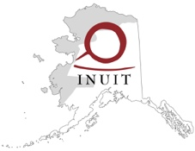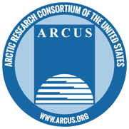

Application Requirements
For the purposes of this opportunity, an Indigenous scholar is defined as a person who is an expert within their own knowledge system. No formal education is required. Candidates should be Indigenous persons with U.S. citizenship. The applicant must complete all sections below for consideration.
Applicants may include supplemental information such as a resume, bio, or a relevant photograph with their application, but this is not required. Further information and an online application form is available at https://www.arcus.org/indigenous-scholars.
Please contact Lisa Sheffield Guy at lisa@arcus.org or 907-474-1600, with any questions.

Applications are due by 5:00 PM AKST on Thursday, 15 February 2018

SCHOLAR Contact Information
Name
Street Address or PO Box
City ST ZIP Code
Phone
E-mail Address

questions
Please provide an answer to each question below. Include additional pages if needed.

What issue is most important to you/your community that you feel policy-makers in Washington, D.C. should know more about?

How might you and/or your community benefit from the opportunity to speak about this issue with Arctic policy- and decision-makers?

What types of individuals or groups are you hoping to meet and share with on your trip (if you are unsure, we will help you find the right people), and what format would you like those meetings to take (one-on-one conversation, round-table discussion, interviews with media, etc.)?

What information or new perspective would you want a policy- or decision-maker to gain a better understanding of and learn about, especially for their future work in the Arctic?

When you return home, do you have ideas about how to share your experience with others? If so, what will you do to inform others about your trip, the meetings you were involved in, and the other benefits of this opportunity?

Agreement and Signature

By submitting this application, I affirm that the STATEMENTS MADE ABOVE are true and complete.
Name (printed)
Signature
Date

thank you!

Thank you for applying to this opportunity. Please send completed forms via email to Lisa Sheffield Guy, lisa@arcus.org or by mail to Arctic Research Consortium of the U.S., 3535 College Road – Suite 101, Fairbanks, AK 99709-3710.

