SEA ICE OUTLOOK

2016 Report

Template with Core Requirements

for Pan-Arctic Contributions

and
Guidelines for Submitting Optional
Alaskan Regional Outlook, Figures, and Gridded Data

Submission Guidelines:

The submission deadline is 6:00 pm (AKDT) Monday, 13 June 2016 (firm) and all submissions should be sent to sio2016@arcus.org. Contributions received after the deadline will be posted to the website but not incorporated into the Outlook report or discussion.

Questions may be directed to Betsy Turner-Bogren, ARCUS (betsy@arcus.org)

Core Requirements for Pan-Arctic Contributions:
* REQUIRED

- *Name of Contributor or name of Contributing Organization and associated contributors as you would like your contribution to be labeled in the report (e.g., Smith, or ARCUS (Wiggins et al.)).

1b. (Optional but helpful for us): Primary contact if other than lead author; name and organization for all contributors; total number of people who may have contributed to your Outlook, even if not included on the author list.

- * Contributions submitted by a person or group not affiliated with a research organization, please self-identify here:
_______ Yes, this contribution is from “Citizen Scientists.”

- * Do you want your contribution to be included in subsequent reports in the 2016 season?
________ Yes, use this contribution for all of the 2016 SIO reports (this contribution will be superseded if you submit a later one).
________ No, I/we plan to submit separate contributions for subsequent reports.
________ No, I only want to participate this time.

- *"Executive summary" of your Outlook contribution: in a few sentences (using 300 words or less) describe how and why your contribution was formulated. To the extent possible, use non-technical language.

- *Type of Outlook method:
___dynamic model ___statistical ___heuristic ____mixed or other (specify)

- *Dataset of initial Sea Ice Concentration (SIC) used (include name and date; e.g., “NASA Team, May 2016”):

- Dataset of initial Sea Ice Thickness (SIT) used (include name and date):

8. If you use a dynamical model, please specify:
a) Model name:
b) Information about components, for example:
Component Name Initialization (e.g., describe Data Assimilation)
Atmosphere CAM5 2016 RCP8.5 integration
Ocean NEMO2 DA - NCODA system
Ice TED DA - EnKF SIC only

c) Number of ensemble members and how they are generated:

d) For models lacking an atmosphere or ocean component, please describe the forcing:

9. *Prediction of September pan-Arctic extent as monthly average in million square kilometers. (To be consistent with the validating sea ice extent index from NSIDC, if possible, please first compute the average sea ice concentration for the month and then compute the extent as the sum of cell areas > 15%.)

10. Prediction of the week that the minimum daily extent will occur (expressed in date format for the first day of week, taking Sunday as the start of the week (e.g., week of 4 September).

11. *Short explanation of Outlook method (using 300 words or less). In addition, we encourage you to submit a more detailed Outlook, including discussions of uncertainties/probabilities, including any relevant figures, imagery, and references.
12. If available from your method for pan-Arctic extent prediction, please provide:

a) Uncertainty/probability estimate such as median, ranges, and/or standard deviations (specify what you are providing).

b) Brief explanation/assessment of basis for the uncertainty estimate (1-2 sentences).

c) Brief description of any post processing you have done (1-2 sentences).

d) Raw (and/or post processed) forecasts for this year and retrospective forecasts in an excel spreadsheet with one year on each row and ensemble member number on columns (specifying whether raw or post processed).

Submitting an Alaskan Regional Outlook (Optional, yet encouraged):
Please submit a total extent for the Alaskan region, defined here as the combination of the Bering, Chukchi, and Beaufort seas. If possible use the definition from the NSIDC Arctic sea ice regional graphs and time series from the mask below, which is on the 25km by 25km polar stereographic projection used for the passive microwave satellite data. The mask, provided as a netcdf file, is available on the SIPN Call for Sea Ice Contributions (https://www.arcus.org/sipn/sea-ice-outlook/2016/june/call). For questions about the format or this request, please contact Muyin Wang (muyin.wang@noaa.gov).

For your submission:

Provide responses for the Alaska Regions for items 9-12 from the pan-Arctic Outlook template above, and respond to items 13 and 14 below.

13) Tell us how you defined the region: either say NSIDC definition, or if you must use your own definition, describe it.

14) Tell us the maximum possible ice extent if every ocean cell in your region were ice covered. For example, if your model uses exactly the same grid as the satellite data, the area would be 4.00x10⁶ km². The maximum possible extent is probably much larger than your actual Alaskan Regional Outlook. Be sure to exclude land and islands.

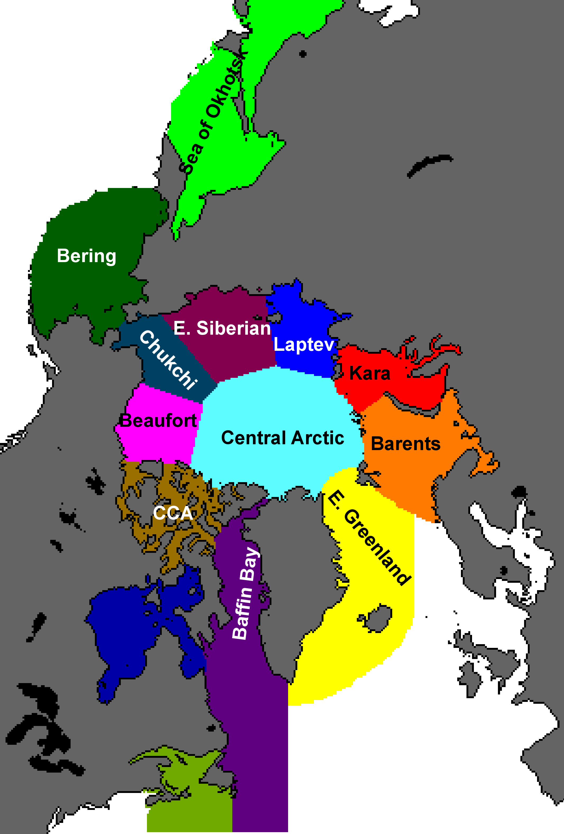

Submitting Figures and Gridded Data for Other Regional Contributions (Optional):
These are optional but strongly encouraged for all participants whose methods provide information at the local scale. If you cannot contribute now, please read on anyway so you can take steps to provide the information in the future.

Please contact Edward Blanchard-Wrigglesworth via email (ed@atmos.uw.edu) for questions and to arrange submission of your figures and/or data.

- Provide a spatial forecast map for September mean ice extent (e.g., jpg, tiff, pdf). If your method predicts sea ice extent (SIE) directly, average it in time and across ensemble members, if you have them, for September (giving values between 0 and 100% inclusive). If your method predicts sea ice concentration (SIC) directly, please average it in time to make a monthly mean SIC, then convert it to SIE (grid cells with SIC<15% are assigned SIE=0% and SIC>=15% are assigned SIE=100%). Finally average across ensemble members, if you have them. We refer to this field as a sea ice probability (SIP).
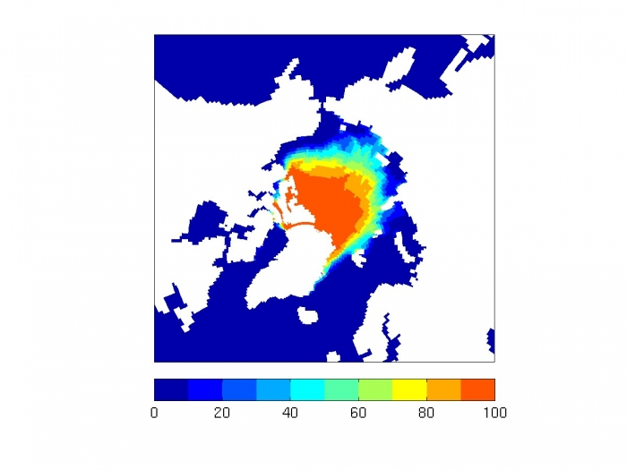
Figure above is sample of SIP (i.e., ensemble mean SIE) in percent for a random year from CESM1.1.

- Provide a spatial map of the first ice-free date (IFD; Julian Day when SIC<15% or SIE=0%) in 2015. Ideally the date is derived from daily frequency output of SIC. For IFD, identify ocean (SIC<15% upon initialization) with the Julian day of the start date (July 1 is day 182) and ice points that always have SIC>15% with the end date (Sep 31 is day 273). Also provide a map of one standard deviation across ensemble members, if you have them.

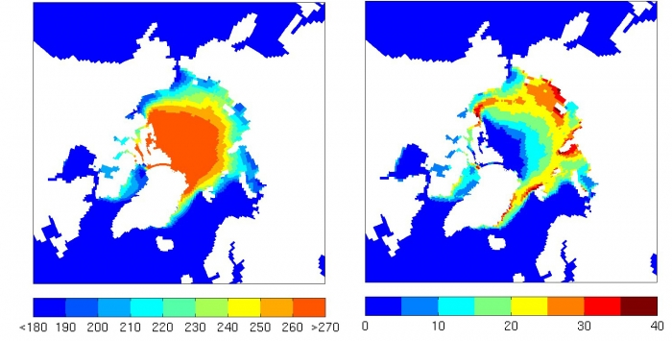

Figure on left: Sample of IFD (first ice free date as Julian Day) ensemble mean.
Figure on right: Sample std dev of IFD across the ensemble. Data are from a random year from CESM1.1.

Use the following naming convention for filenames (for example if your surname is Smith) and you are forecasting September 2016 using June initial data:
Smith_Sep2016_Junedata_SIP.jpg
Smith_Sep2016_Junedata_IFD.jpg
Smith_Sep2016_Junedata_stdIFD.jpg
Smith_Sep2016_Junedata_README.txt (explaining how you computed SIP and IFD, follow link for an example)

3. Provide your data for SIP and IFD (see maps in #1 and #2 above) in a format with geographic information included or in NetCDF, if possible. We will work with the format provided as long as all relevant grid/projection/data format information is provided.

a) Provide the data on your native grid and, if possible, on a common 1-degree grid.

b) Include latitude (lat) and longitude (lon) grid information in degrees, and for your native grid, include gridcell area (areacello) in square meters. For SIP and IFD, identify land points in your data field with the identifier -999. Include the std. dev. of IFD (stdIFD) in the same file with IFD.

Note: If you must submit text, please use a column format in the order: lat, lon, areacello (for the file that is on your native grid), and finally the data field. Separate columns with spaces (preferred), commas, or tabs. Do not include any information such as variables names at the beginning. Provide that information in a separate metadata file with all the information needed to understand the file.

c) For the common grid, please include latitudes 60N, 61N, 62N … 89N and longitudes 180W, 179W, … 179E (or 0 to 360E). No need to include areacello for the common grid.

d) If you provide NetCDF files use the following naming convention (or as necessary for an equivalent set of GeoTIFF files) follow links for an example of each:
Smith_Sep2016_Junedata_SIP_native.nc
Smith_Sep2016_Junedata_IFD_native.nc
Smith_Sep2016_Junedata_SIP_common.nc
Smith_Sep2016_Junedata_IFD_common.nc

e) Or if you must use text, please provide all of the following files:
Smith_Sep2016_Junedata_SIP_native.txt
Smith_Sep2016_Junedata_SIP_native_meta.txt
Smith_Sep2016_Junedata_IFD_native.txt
Smith_Sep2016_Junedata_IFD_native_meta.txt
Smith_Sep2016_Junedata_SIP_common.txt
Smith_Sep2016_Junedata_SIP_common_meta.txt
Smith_Sep2016_Junedata_IFD_common.txt
Smith_Sep2016_Junedata_IFD_common_meta.txt

For questions, please contact Edward Blanchard-Wrigglesworth via email (ed@atmos.uw.edu)

