  - Study of Environmental Arctic Change
  - (SEARCH)

Science Steering Committee (SSC)

New Member Orientation Packet

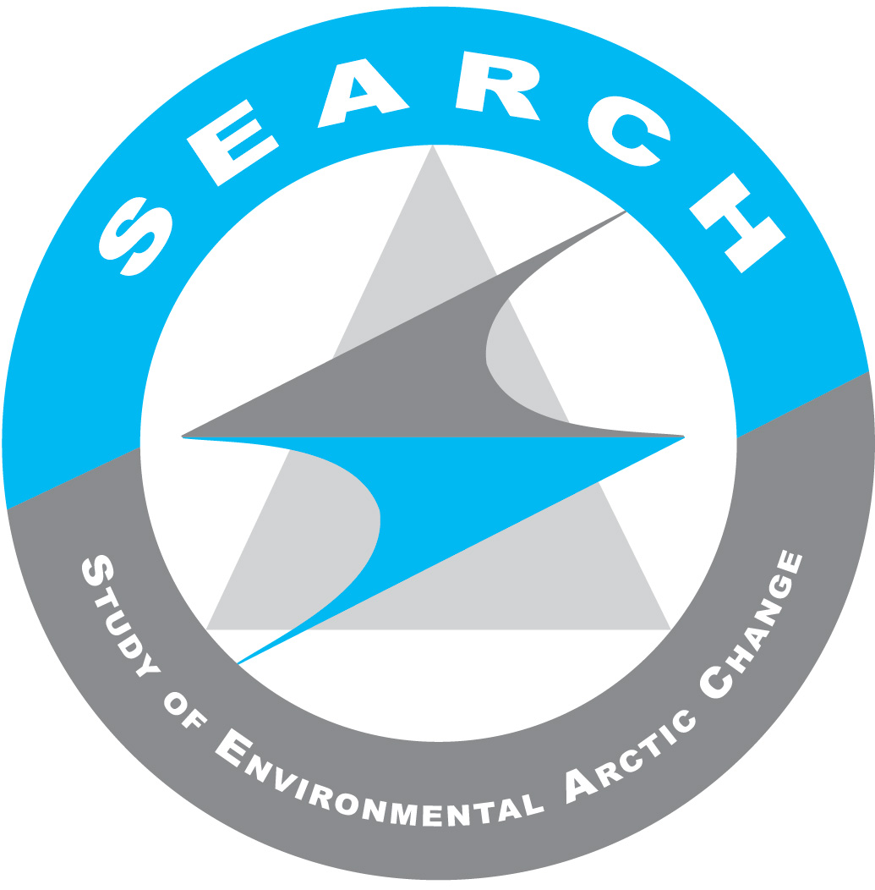

SEARCH Vision, Mission, & Science Goals
See: http://www.arcus.org/search-program/vision

SEARCH Vision: Scientific understanding of arctic environmental change to help society understand and respond to a rapidly changing Arctic.

SEARCH Mission: To provide a foundation of arctic change science through collaboration with the research community, funding agencies, and other stakeholders. Towards this mission, SEARCH:

SEARCH's Science Goals & Corresponding Action Teams:
- “Sea Ice Action Team” Goal: Improve Understanding, Advance Prediction, and Explore Consequences of Changing Arctic Sea Ice
- “Permafrost Action Team” Goal: Document and Understand How Degradation of Near-Surface Permafrost Will Affect Arctic and Global Systems
- “Land Ice Action Team” Goal: Improve Predictions of Future Land-ice Loss and Impacts on Sea Level
- Analyze Societal and Policy Implications of Arctic Environmental Change
  - This goal is integrated across all three of the SEARCH Action Teams.

Learn more about the SEARCH 5-Year Science Goals & Objectives:
http://www.arcus.org/search-program/goals

SEARCH Program Structure

Science Steering Committee
SEARCH is lead by a Science Steering Committee (SSC). The SSC ensures that the program is achieving its vision, mission and long-term science goals by providing oversight and guidance to the program and to the SEARCH Executive Director. A Chair and Vice-Chair provide leadership for the SSC.

Executive Director
The SEARCH Executive Director is responsible for implementing the SEARCH program and overseeing its day-to-day activities. This position is based at the International Arctic Research Center (IARC) at the University of Alaska Fairbanks.

Action Teams
Three Action Teams currently work with the SSC in achieving SEARCH's science goals:
- “Sea Ice” Action Team
- “Permafrost” Action Team
- “Land Ice” Action Team

Observing Change Panel (OCP)
The overall goal of the OCP is to work with the SEARCH Science Steering Committee to guide the development of the observation component of SEARCH.

Project Office
The SEARCH Project Office is housed at the Arctic Research Consortium of the U.S. (ARCUS). ARCUS staff work closely with the SEARCH SSC, Executive Director and Action Teams to provide strategic planning, project management, meeting planning, and communication activities. Currently, the SEARCH program office is staffed at the level of about 1.3 FTEs.

SEARCH Organizational Diagram

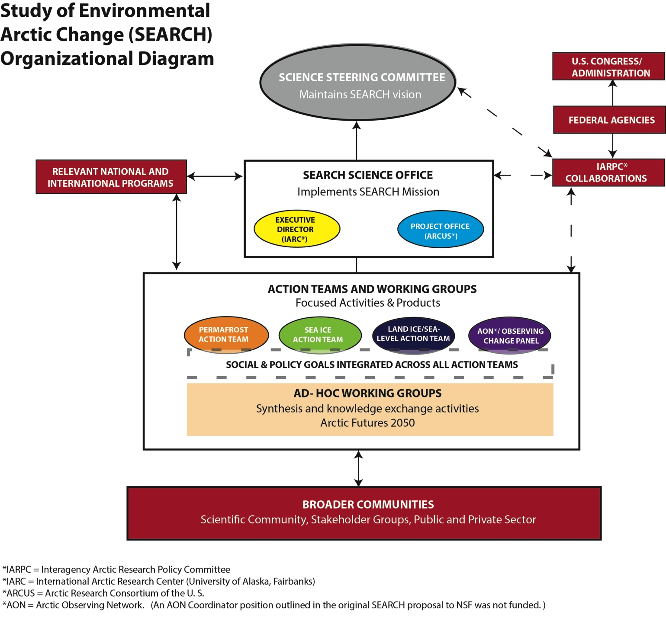

SEARCH People & Contact Info

SEARCH Science Steering Committee Members
http://www.arcus.org/search-program/sciencecoordination/ssc-committee

Group Email for the SSC: SEARCH_SSC@arcus.org
The group email above is used by ARCUS staff and SSC members to communicate with the full SEARCH SSC membership. As a group email member you are also welcome and invited to send emails and attachments directly to the entire SSC via this address. However, ARCUS staff will need to provide “send to” permissions to the email(s) that you will use. Please send any primary or secondary email addresses that should be added to the group email safe list to brit@arcus.org. Any email sent to the group list from an email account not on the safe list will first be redirected to ARCUS staff for review.

SSC group email members include:
- Hajo Eicken (SSC Chair): heicken@alaska.edu
- Caspar Ammann: ammann@ucar.edu
- Robert Bindschadler: robert.a.bindschadler@nasa.gov
- Uma Bhatt: bhatt@gi.alaska.edu
- William (Breck) Bowden: breck.bowden@uvm.edu
- George Kling: gwk@umich.edu
- Karen Pletnikoff: karenp@apiai.org
- Stephen Vavrus: sjvavrus@wisc.edu
- Courtney Carothers: clcarothers@alaska.edu
- Marika Holland: mholland@ucar.edu
- *Olivia Lee (Research Associate): oalee@alaska.edu
- ARCUS staff
- SEARCH Executive Director (pending new hire)

*Olivia is not a member of the SSC but works closely with Hajo Eicken as a Research Associate on some SEARCH-related projects.

SEARCH Executive Director
This position has not yet been filled.

SEARCH Action Team Leaders & Staff
Group Email for the Action Team Leaders & Staff: SEARCH_AT_LEADS@arcus.org
SSC Members are not members of the SEARCH AT Leads group email. As a result, any message you send to this address will first go to ARCUS staff for review and posting. The SEARCH AT Leads group email includes ARCUS staff, the SEARCH ED (pending new hire) as well as the Action Team and Observing Change Panel contacts listed below.

Land Ice Action Team
- Ted Scambos (Co-Chair): teds@nsidc.org
- Fiamma Straneo (Co-Chair): fstraneo@whoi.edu
- (SSC Liaison TBD)

Permafrost Action Team
- Ted Schuur (Chair): Ted.Schuur@nau.edu
- Christina Schaedel (Postdoctoral Associate): Christina.Schaedel@nau.edu
- (SSC Liaison TBD)

Sea Ice Action Team
- Jennifer Francis (Co-Chair): francis@imcs.marine.rutgers.edu
- Henry Huntington (Co-Chair): hph@alaska.net
- Matt Druckenmiller (Facilitator/Communicator): mldruck@gmail.com
- (SSC Liaison TBD)

Observing Change Panel (OCP)
- Craig M. Lee (Chair): craig@apl.washington.edu
- Complete OCP Member list: http://www.arcus.org/search-program/sciencecoordination/observing

SEARCH Program Office Staff (ARCUS)
The ARCUS staff below share the responsibilities of the SEARCH program office, along with their other ARCUS projects and responsibilities. Currently, the funding for ARCUS staff time for SEARCH totals approximately 1.3 FTEs.
- Helen Wiggins (Director of Programs): helen@arcus.org
- Brit Myers (Project Manager): brit@arcus.org
- Lisa Sheffield-Guy (Project Manager): lisa@arcus.org
- See other ARCUS staff: http://www.arcus.org/arcus/staff

National Science Foundation
SEARCH is funded through a collaborative grant, “Collaborative Research: Research, Synthesis, and Knowledge Transfer in a Changing Arctic: Science Support for the Study of Environmental Arctic Change (SEARCH)” from the National Science Foundation Arctic Sciences Section to the International Arctic Research Center/U. of Alaska Fairbanks (Grant #: PLR-1331100; PI: Hajo Eicken) and ARCUS (Grant #: PLR-1331083; PI: Helen Wiggins).

National Science Foundation Contacts
- Neil Swanberg (Arctic System Science & SEARCH Program Director): nswanber@nsf.gov
- William Ambrose (Arctic Observing Network Program Director): wambrose@nsf.gov
Interagency Arctic Research Policy Committee (IARPC)
On an interagency level, SEARCH interacts with Interagency Arctic Research Policy Committee (IARPC), primarily through membership in the IARPC Collaboration Teams as well as ongoing discussions with the IARPC Secretariat.

Interagency Arctic Research Policy Committee (IARPC) Contacts
- Simon Stephenson (IARPC Executive Director): Simon_N_Stephenson@ostp.eop.gov
- Sara Bowden (IARPC Executive Secretary): bowden@arcus.org
Members of the SSC are strongly encouraged to join the IARPC Collaborations website (via a member account) and to participate in one or more of the IARPC Collaboration Teams and regular webinars.

To request an IARPC Collaborations account, please sign up here: http://www.iarpccollaborations.org/request-account.html

SEARCH SSC Member Role & Responsibilities
- Guide overall directions, priorities, and major activities.
- Monitor progress toward the SEARCH program’s five-year science goals and adjust the trajectory of program activities to ensure these goals are achieved.
- Promote and communicate SEARCH activities and plans with the scientific community, federal agencies, relevant organizations, and stakeholders.
- Establish productive linkages and partnerships to other programs and efforts.
- Work with the SEARCH Executive Director to develop annual program plans, articulate clear milestones, monitor activities, and make adjustments to program plans as needed.
- Set priorities for the SEARCH Executive Director.
- Attend and be active participants in SEARCH SSC teleconferences and in-person meetings.
- Review the SEARCH program structure and Terms of Reference on an annual or as-needed basis.
- Represent the interests of the broader Arctic research community.
- Work with the scientific community to develop the next set of five-year goals and lead development of any related science or implementation plans.

SEARCH SSC Meetings & Calls

Monthly Teleconferences
The SEARCH SSC and Action Team Leads participate in a joint monthly teleconference each month. There is no set schedule for the call. Instead, calls are scheduled based on information SSC Members submit to the SEARCH Program Office via Doodle scheduling polls. Call-in information is provided by ARCUS staff.

In-Person Meetings of Science Steering Committee and Action Team Leads
At least one in-person meeting of the SEARCH SSC and Action Team Leads will take place each program year. The dates and location are determined by ARCUS and the SSC, and ARCUS covers travel costs of SSC members.

In addition, a second in-person meeting is often scheduled as a meeting of opportunity in association with a large science conference, such as the American Geophysical Union (AGU) Fall Meetings in San Francisco.

SEARCH Background Materials & SSC Online Workspace

The following information sources provide a useful introduction to the SEARCH program and can be found on the SEARCH website or SSC private online workspace: http://www.arcus.org/search-program/ssc/internal (Login: SEARCH Password: private)
  - SSC Monthly Teleconference Minutes (online workspace)
  - SEARCH Draft Terms of Reference under review for SSC adoption (online workspace)
  - NSF Grant Proposal as submitted* (online workspace)
  - NSF Report for SEARCH Program Year 1 (online workspace)
  - Arctic Observing Network (AON) Position Paper
http://www.arcus.org/files/page/documents/18992/aon_search_positionpaper_final_1april2015.pdf
  - Kick-off Meeting Materials:
http://www.arcus.org/search-program/meetings/2014/kick-off-tactics
  - SEARCH homepage:
http://www.arcus.org/search-program

*Note: The AON Coordinator position outlined in the NSF Proposal was not funded.

Please contact ARCUS program office staff with any questions pertaining to these materials or for further details regarding SEARCH’s current activities and/or program history.

