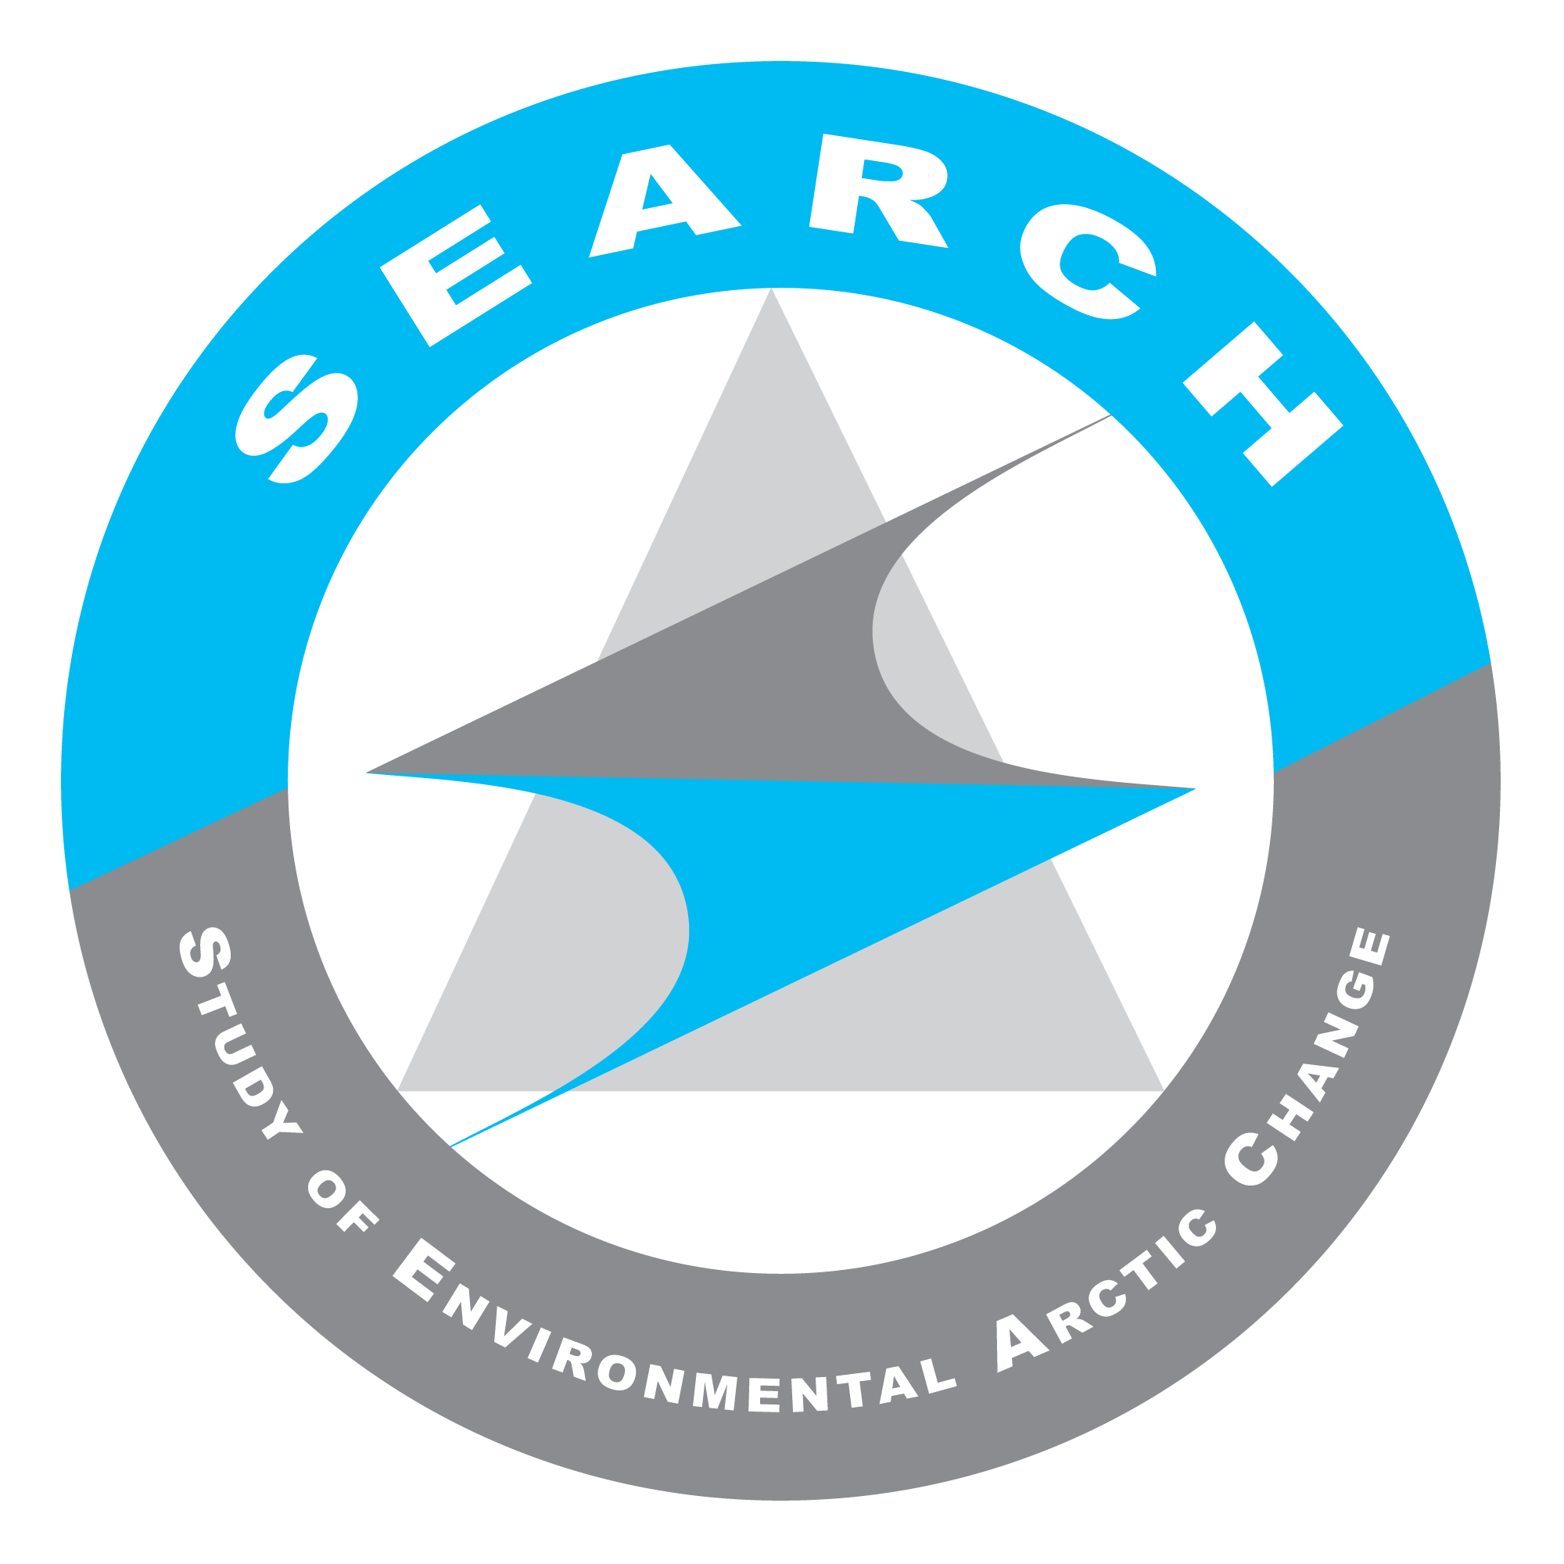
SEARCH Science Steering Committee
& Action Team Leads Meeting
19 February 2016
Decision Summary, Action Items, & Notes

Present: Betsy Baker, Brendan Kelly, Brit Myers, Caspar Ammann, Christina Schädel, Dee Williams, George Kling, Hajo Eicken, Henry Huntington, Karen Pletnikoff, Lisa Sheffied-Guy, Matthew Druckenmiller, Marika Holland, Robert Bindschadler, Robert Rich, Uma Bhatt, Olivia Lee, Craig Lee.

Decision Summary:
- Decision: The SSC will move to a quarterly meeting schedule as proposed in Read-ahead C of the February 19 meeting documents.
- Decision: The SEARCH Science Office will move forward with the proposal to develop and use the internal & external timelines provided in Read-ahead F-1 & F-2 to monitor and track SEARCH program progress.
- Decision: The SEARCH Science Office will proceed with new SSC member nominations as proposed: nominations would be solicited via an open call through the end of March, current SSC members would then be asked to select their top 4 candidates at the SEARCH SSC/AT Leads May meeting.
- Decision: SEARCH will proceed with standing-up a new Communications Working Group to pursue the activities outlined in the draft charge proposed for the group (Read-ahead I in the February 2016 document binder). The group will remain active at least until the May 2016 SSC meeting, where it will be expected to deliver an initial report to the SSC on its activities for review/feedback. A final written report will be submitted to the SSC at the August 2016 meeting.

Action Items:

ASSW/AOS Update:
- ACTION: Bob Bindschadler asked Hajo to write down some of his thoughts about how the LAIT can engage with AOS efforts/participant initiatives so that he can share it with Fiamma Straneo and Ted Scambos (Hajo Eicken & Bob Bindschadler)

Review of New Milestones & Updated Timeline for Year-2 Plan (Requested by NSF):
- ACTION: On Monday 22 February Brendan will send out a request asking Action Team Leads to review the latest milestone table and timeline to make sure they can stand behind the submission of these materials to NSF. Action Team feedback should be provided by Monday, 29 February. (Brendan & Action Team Leads)
- ACTION: If SSC Members find any issue with the year-2 plan milestones/timeline they should Brendan, highlighting the issue and offering a possible solution before February 29th (SEARCH SSC).
- ACTION: The SEARCH Science Office will update the milestone description that that incorrectly states the PCN synthesis project documents be reviewed online (SEARCH Science Office)
- ACTION: Christina or the SEARCH Science Office will be sure to add the Nature Climate Change product to the year-2 plan list of milestones. (Christina or SEARCH Science Office)

Other Items:
- ACTION: Brit will follow-up with Christina about organizational support for the June Permafrost Carbon Network meeting. (Brit)
- ACTION: The SEARCH Science office will follow-up with Dee to learn more about the federal agency science advisory groups he feels SEARCH might want to engage and then make some suggestions to the SSC & AT Leads about opportunities to engage. (SEARCH Science Office)
- ACTION: Caspar highlighted a number of important topics that he hopes the SEARCH SSC and AT Leads will be able to discuss prior to the May meeting in sub-groups (including data policies, cross-cutting themes, brainstorming activities for the coastal erosion theme identified today). He encouraged everyone to look at the discussion topics listed on the SEARCH agenda and to volunteer to help move these conversations forward by sending an email to him, Brendan or ARCUS staff. (SEARCH SSC & AT Leads)
- ACTION: Brit will send around a Doodle poll early next week to identify dates for the May meeting. (Brit)
- ACTION: Caspar will check with NCAR to see if SEARCH can meet there in May. (Caspar)

Summary of Discussions & Action Items:

- ASSW/AOS Update
- Hajo encouraged everyone to visit the AOS website: http://www.arcticobservingsummit.org/ and reviewed the six working group theme descriptions: http://www.arcticobservingsummit.org/aos-2016-theme-descriptions
- There will be funding agencies present at ASSW such as ESA/PolarNet to help address questions about how to create funding mechanisms for sustained international polar observations. (See Working Group theme 1).
- Goal for all ASSW thematic working groups is to come up with specific recommendations and action plans that will be reviewed at the end of the summit by the Arctic Council working groups.
- Theme 2: Technology and Innovation - will focus mostly on UASs.
- Theme 3: Contributions of the Private Sector and Industry - will focus on platforms and vessels of opportunity. Private sector is well engaged and oil/gas industry, fishing, and mining will be there.
- Theme 4: Actor and Stakeholder engagement and needs - will be co-led by Craig Fleener
- Theme 5: Arctic Observations in the Context of Global Observing Initiatives – this is emerging as the core theme of the summit overall. Barbara Ryan of the GEO Secretariat is giving a keynote lecture, Director of World Climate Research program & high-level NOAA officials (including assistant administrator for NOAA satellites, Stephen Volz) will also be there. There should be quite a bit of discussion about how to link global and Arctic observations.
- Theme 6: Interfacing Indigenous Knowledge, Community-based Monitoring and Scientific Methods – quite a bit of activity taking place in the background by this group in regard to identifying best practices.
- Caspar asked Hajo if he thought there was anything that SEARCH could be doing to move it’s own Arctic observing agenda forward in the run-up to & during AOS. Hajo suggested doing more to build partnerships and felt that this was something that a successor to the Observing Change Panel could oversee. Connecting with industry & private sector around the issue of Arctic vessels and platforms of opportunity programs. Engage to ensure high quality data centers are in place, things are interoperable, observing protocols & practices exist that are rigorous. He felt that there would be seeds of projects emerging from working groups (such as Theme 6) that SEARCH could help lead at the national level over the next few years before everyone convenes at the next Arctic Observing Summit.
- Bob Bindschadler spoke about the relevance of Theme 1 (sustained funding) in the context of the Land Ice Action Team’s efforts to develop GrIOOS and asked Hajo what he thought the team should do to take advantage of AOS – particularly because there wouldn’t be any members of the Land Ice Team attending the summit.
- Hajo said the EU is pushing for better international coordination for Arctic activities, 2 big proposals going into Horizons2020 have a Greenland ice-sheet component that it will be important for GrIOOS to link in with. EUPolarNet should be followed closely/engaged also because its initiative is focused on leveraging/coordinating their Arctic research activities more effectively. It is led by the Alfred Wegener Institute, Nicole Biebow. This group will set priorities that will be followed up on by national organizations like the Norwegian Polar Institute, Alfred Wegener Institute, British Antarctic Survey’s Arctic Group.
- ACTION: Bob Bindschadler asked Hajo to write down some of his thoughts about how the LAIT can engage with AOS efforts/participant initiatives so that he can share it with Fiamma Straneo and Ted Scambos (Hajo Eicken & Bob Bindschadler)

- New/Updated Science
- Uma presented a science update describing trends in Arctic greening and browning based on remote sensing data & the NDVI index.
- (See meeting recording timeframe: 9:04-16:45)

- Executive Director’s Report (Focus New NSF Requests for Year-2 Plan)
  - Brendan shared a recent communication from Neil Swanberg at NSF saying they can approve SEARCH’s year-2 plan but that they also need tables & a timeline that the Science Office has been developing (sent to SSC/Action Team Leads on Thursday 18 February).
  - Brendan shared the concern expressed by some at NSF that the current plan narrative gives the impression “that the [SEARCH] outcomes are going to be a series of meetings, white papers and press releases” and that they would prefer to see more specificity/clarity around science outcomes.
  - ACTION: On Monday 22 February Brendan will send out a request asking Action Team Leads to review the latest milestone table and timeline to make sure they can stand behind the submission of these materials to NSF. Action Team feedback should be provided by Monday, 29 February. (Brendan & Action Team Leads)
  - ACTION: If SSC Members find any issue with the year-2 plan milestones/timeline they should Brendan, highlighting the issue and offering a possible solution before February 29th (SEARCH SSC).
  - Bob Bindschadler felt these materials looked good from the perspective of the Land Ice Action Team.
  - Betsy Baker said that she agrees that in the current plan the great science doesn’t ‘jump out’ as much as it should and she asked AT Leads about what science outcomes they would like to highlight. She also asked about the possibility of deviating from standard form report. Brendan recommended keeping the same format because NSF specifically requested it.
  - Christina expressed her hesitation to set specific due dates for the production of various science products because the network the Permafrost Action Team is working with is based on the efforts of unpaid volunteers.
  - Brendan felt that it was better to list the science activities and provide approximate timelines (with caveats) rather than not show/list them at all. He pointed to the timelines that Ted Schuur had already shared at previous meetings as good examples.
  - Christina noted that the 1-page syntheses outlining the science projects of the PCN are not publically available on the PCN website. They are password protected.
  - ACTION: The SEARCH Science Office will update the milestone description that that incorrectly states the PCN synthesis project documents be reviewed online (SEARCH Science Office)
  - Brendan also felt that it might be very helpful if the Land Ice Action Team could explain where they are going/what happens next after they finish their follow up to last December’s GrIOOS workshop. He felt that explaining how GrIOOS fits into a longer-term vision for the AT would help NSF.
  - Brendan also mentioned the previous concern that had been expressed about the Sea Ice Action Team’s communication focus and the ongoing need to clearly articulate the science outcomes as well.
  - Uma clarified that it was specifically the “advance science” sections of the milestone table that need to be fleshed out/highlighted more.

- New Meeting Schedule
- Decision: The SSC will move to a quarterly meeting schedule as proposed in Read-ahead C of the February 19 meeting documents.
- Caspar expressed his hope that between quarterly meetings work would still be taking place via the working groups/action teams/ad hoc SSC subgroups in the background to advance SEARCH goals & activities. These groups would present to the SSC their efforts at the quarterly meetings and the SSC could offer their response/feedback to these activities.

- Budget Tracking and Reporting
- Decision: Action Team leads will provide a quarterly budget report of their SEARCH spending using the template provide in Read-ahead E of the February 19 meeting documents.
- Decision: The SEARCH Science Office will move forward with the proposal to develop and use the internal & external timelines provided in Read-ahead F-1 & F-2 to monitor and track SEARCH program progress.
- Caspar discussed balancing the need to make sure the entire SEARCH program was remaining on track with the desire not to make reporting requirements for the ATs too onerous. He promoted the idea of using ad hoc groups to increase the capacity of each AT to conduct various activities & help spread the burden and encouraged the SSC/AT Leads to be more proactive in this direction.
- SSC Member Rotations
- Brendan asked the SSC for suggestions about the type of expertise that would be desirable for new SSC members.
  - Hajo flagged the spreadsheet of potential SSC candidates that had been developed during the last rotation. Brendan said that he had received a copy of the document.
  - Bob Bindschadler discussed “coastal erosion” as a topic that links across three action teams and hits stakeholder concerns. He said he talked to Bob Kopp from Rutger’s University (http://www.bobkopp.net/) about this at the Arctic Encounter symposium.
  - George Kling talked about the SSC’s earlier desire to select new SSC members with experience working with SEARCH Action Teams . He felt this would make it easier for the SSC to understand how hard/easy it might be to achieve the things that the SSC was asking of the ATs. He also emphasized that the freshwater ecosystems perspective would be missing once he and Breck Bowden rotated off the committee. He said he had provided some names in the past of individuals with this type of expertise.
  - Karen urged SEARCH to remain committed to keeping someone involved in local science on the SSC, either through the tribal environmental programs or permanent participants from the Arctic Council. She felt the SEARCH crossover to stakeholders from rural AK to SEARCH’s science has been valuable and that SEARCH has been viewed as progressive and inclusive for having a position of this kind since 2006.
  - Decision: The SEARCH Science Office will proceed with new SSC member nominations as proposed: nominations would be solicited via an open call through the end of March, current SSC members would then be asked to select their top 4 candidates at the SEARCH SSC/AT Leads May meeting.
- Action Team Reports
- Permafrost Action Team (Christina Schädel)
  - Synthesis Progress
    - Christina just completed an extensive revision for a submission to Nature Climate Change (http://www.nature.com/nclimate/index.html). Topic: Environmental changes on permafrost and increased temperature relation to aerobic vs. anaerobic carbon release. (Note: this product not listed in current year-2 plan).
    - ACTION: Christina or the SEARCH Science Office will be sure to add the Nature Climate Change product to the year-2 plan list of milestones. (Christina or SEARCH Science Office)
    - Christina is now working on a protocol for permafrost soil incubation. She has circulated this to her co-authors and is updating a new version she hopes to submit by May.
  - The USGS-funded post-doc announcement has been review by Steve Gray and is now just about ready to be posted. She said there might be some UAF rules to follow and they will be finding out about that in the coming week.
  - The Action Team has also submitted an ASSW revised short statement. Dave McGuire will present the poster as Christina and Ted Schuur are unable to attend the summit. The poster will talk about the Action Team and synthesis science in general.
  - Christina attended Germany’s annual permafrost meeting in Hamburg, Germany where she presented on the Permafrost Carbon Network, the Permafrost Action Team and some of their synthesis science products.
  - Ted participated in the Arctic Encounter symposium in early January.
  - Hasiuki Saito, member of the Permafrost Modeling Group, participated in the CliC annual meeting in Copenhagen.
  - They have scheduled the next Permafrost Action Team meeting for the last week in February.
  - They are working on organizing the next workshop for the Permafrost Carbon Network in advance of ICOP and hoping to engage Brit for support on those activities. The meeting will take place Sat/Sun before the conference (June 18 & 19).
  - ACTION: Brit will follow-up with Christina about organizational support for the June PCN meeting. (Brit)
  - They have secured additional funding through CliC for the Potsdam meeting of the PCN ($4300 Swiss Francs… which Christina says is the same amount in US Dollars).
- Sea Ice Action Team (Henry Huntington & Matthew Druckenmiller)
  - Henry participated in the Arctic Encounter symposium
  - Jenn has given two D.C. seminars (Arctic Matters & ARCUS Science Seminar Series)
  - A short paper and poster has been submitted to AOS focusing on collaboration, community engagement and science communication. Can use this venue as an opportunity to discuss communications in terms of promoting science collaboration.
  - Following summit they will prepare a lengthier paper on their pyramid approach to communications.
  - Will participate in the SIPN workshop on Polar Prediction in early May
  - Developing a knowledge exchange workshop on Societal Impacts on Arctic Sea Ice Loss. This will be a 2-3 day workshop in Washington D.C. in September for 40-50 participants (scientists, stakeholders and decision-makers). Goal is to discuss opportunities for actionable science. Where science synthesis topics are needed and possible and scoping emerging topics. Papers are likely to result. Working on trying to find additional funding for this.
  - The team has continued to develop summary documents on societal relevant science topics and to curate literature for “lower pyramid” levels of content.
  - Working with ARCUS to design a website. Should have a demo site in the next couple of months. Again, showing communication as a tool to encourage collaboration within the science community.
  - Matt looking at other NSIDC groups for collaboration. NSIDC gets a lot of attention around sea-ice minimum, January minimum etc. He has talked about jointly developing a podcast with the Arctic sea ice news and analysis.
  - Likely that the SIAT will be contributing to the SEARCH communications workgroup.
  - Brendan asked Matt what his thoughts were about the difference between responding to things that have already gotten media attention vs. drawing attention to things that may not be on the public radar. Matt said that NSIDC is often contacted before pieces are published and this helps them target issues to focus on.
  - Matt felt that understanding how things find their way into the media is worth some attention.
- Land Ice Action Team
  - The GrIOOS workshop brought together an international/interdisciplinary group prior to AGU to discuss the network. They made progress identifying and approving-by -consensus priority observation sites.
  - Fiamma will be writing up results by late spring and there will also be an article describing outcomes of the workshop.
  - The tension between the limited amount of fiscal support provided and the amount of labor being asked of the Team remains a big challenge in this group.
  - The LIAT remains focused primarily on finding support for and establishing GrIOOS. Bob feels more attention still needs to be given to stakeholder engagement. Having just attended Arctic Encounter, he feels coastal erosion is a valuable interconnected issue that could be a way forward on this issue.
    - Betsy Baker shared that she had recently been talking to Amy Holman (NOAA) and Jim Gamble (Aleut International Assoc) about the continued segregation of ocean and terrestrial sciences and that she had been thinking about this from a policy/governance perspective. She felt that this coastal erosion was a way not only to engage stakeholders but also to promote integrated science and show where connections have not been made in the past.
    - Bob felt that this might be an area of obvious need for synthesis science and suggested creating an ad hoc group to deal with this topic.
    - Caspar suggested making this a crosscutting theme activity (rather than leaving it to one Action Team).
    - Bob suggested making this a topic of further conversation at the next SSC meeting.
    - Betsy volunteered to be part of this ad hoc group.
  - Caspar also highlighted the fact that Fiamma will be giving the AGU Ocean Sciences Sverdrup lecture.
  - Caspar also posed the critical question of what could be done to find more sources of support for Action Team activities. Brendan made the suggestion of bringing folks onto the SSC and/or LIAT itself that can carry some of the burden.
- Communications Working Group (Bob Bindschadler)
- Bob expressed his view that communication is part of the science. It should link SEARCH’s Action Teams together using a consistent format so that it becomes clear to the consumer where the science is coming from and provides an integrated view of the Arctic.
- Bob discussed the Communications Working Group charge, saying that the working group would not be responsible for “doing” the communications. Rather, the group would put forward a suggested cohesive communication strategy to the SSC for review and that the AT’s could use to help SEARCH develop a more common look and feel.
- Brendan asked if Bob would consider being on the committee and Bob said he would be willing to do this.
- Decision: SEARCH will proceed with standing-up a new Communications Working Group to pursue the activities outlined in the draft charge proposed for the group (Read-ahead I in the February 2016 document binder). The group will remain active at least until the May 2016 SSC meeting, where it will be expected to deliver an initial report to the SSC on its activities for review/feedback. A final written report will be submitted to the SSC at the August 2016 meeting.
- Bob asked about the right size for the group. Brendan felt 4-6 people would be sufficient.
- SEARCH and Agencies (Dee Williams)
- Dee outlined a number of existing engagement opportunities that SEARCH can leverage:
  - 12 IARPC Collaboration Team (input to 5-year plan would be welcome, March 13th meeting at ASSW for this).
  - Opportunity to serve on science advisory boards for all agencies that fund Arctic research initiatives in Alaska (North Slope Science Initiative, BOEM, NPRB, Shell, North Slope Borough Baseline (has external science advisory slots to fill).
  - Arctic Council Working Groups
  - There are also periods in the annual planning cycle of federal agencies when comments are made to the agency science plan. Typically the only funding suggestions received are from other agencies. This need not be the case. SEARCH could engage in this arena.
  - SEARCH could be more active in creating a deliberate nexus between SEARCH’s research priorities and federal funding decisions. This could be done in the form of a letter during key moments in planning cycles.
  - All agencies undertaking federal actions have opportunities for public comment. This is another area that typically goes un-used by the science community in an organized fashion.
  - Dee feels like there is a parallel universe (continued segregation) between processes that are centered in Washington D.C. and those that are centered in Alaska and that this is an interface that could be dramatically improved with SEARCH involvement. Dee flagged, for example, the lack of NSF representation at local AK meetings.
  - Dee felt that developing a shared blueprint for establishing priorities (which SEARCH has proposed/discussed in the past) remains important and that building out a deliberate nexus/network for dialogue will support this effort.
  - Dee shared that he is a member of the NSSI group and that there is a moment each year when all the agencies come together and explicitly state their funding priorities for the year. To reduce duplication but also to encourage exchange about new opportunities and coordinated efforts to optimize outcomes.
  - He feels that if there is an opportunity to do something similar at a broader national scale – bring agencies w/ resources together at an optimal moment around a shared blueprint to discuss national resources can cover the field of priorities. Dee feels this currently only happens in a virtual universe. SEARCH might be able to promote a more open discussion similar to regional discussions done through NSSI.
  - Brendan said he was struck by the idea of SEARCH being able to step into the NSF breach of not being part of the regional discussions in AK.
  - Brendan said that the push for national prioritization has occurred via IARPC and it has been hard to get the agencies to move in that direction.
  - ACTION: The SEARCH Science office will follow-up with Dee to learn more about the federal agency science advisory groups he feels SEARCH might want to engage and then make some suggestions to the SSC & AT Leads about opportunities to engage. (SEARCH Science Office).
  - Caspar raised the point that SEARCH’s uninvited effort to provide advice to federal agencies in the past has not always been received well. He felt SEARCH would need to make sure that it receives a good invitation to participate before engaging too heavily in some efforts.
- Summary and Next Meeting (Caspar Ammann)
- Caspar urged everyone to go over the year-2 milestones/timelines and make sure they highlight the Action Team science sufficiently
- ACTION: Caspar highlighted a number of important topics that he hopes the SEARCH SSC and AT Leads will be able to discuss prior to the May meeting in sub-groups (including data policies, cross-cutting themes, brainstorming activities for the coastal erosion theme identified today). He encouraged everyone to look at the discussion topics listed on the SEARCH agenda and to volunteer to help move these conversations forward by sending an email to him, Brendan or ARCUS staff.
- Caspar flagged a Scenarios community of practice discussion taking place on March 1st. This event is something that ARCUS has convened. A number of SEARCH members have been invited to participate. However, this conversation will not be internal to SEARCH. (Please email brit@arcus.org if you would like more information.)
- Caspar discussed his hope that SEARCH will be adequately represented on the IARPC Collaboration Teams moving forward and flagged the need to figure out the best way to do this as a topic to revisit in future conversations.
- ACTION: Brit will send around a Doodle poll early next week to identify dates for the May meeting. (Brit)
- ACTION: Caspar will check with NCAR to see if SEARCH can meet there in May. (Caspar)
- A second in-person meeting in Nov/Dec in Washington, D.C. has also been proposed. SEARCH’s external review (a year-2 requirement of NSF’s) that was not discussed explicitly during today’s meeting, could possibly be part of this D.C. meeting.

