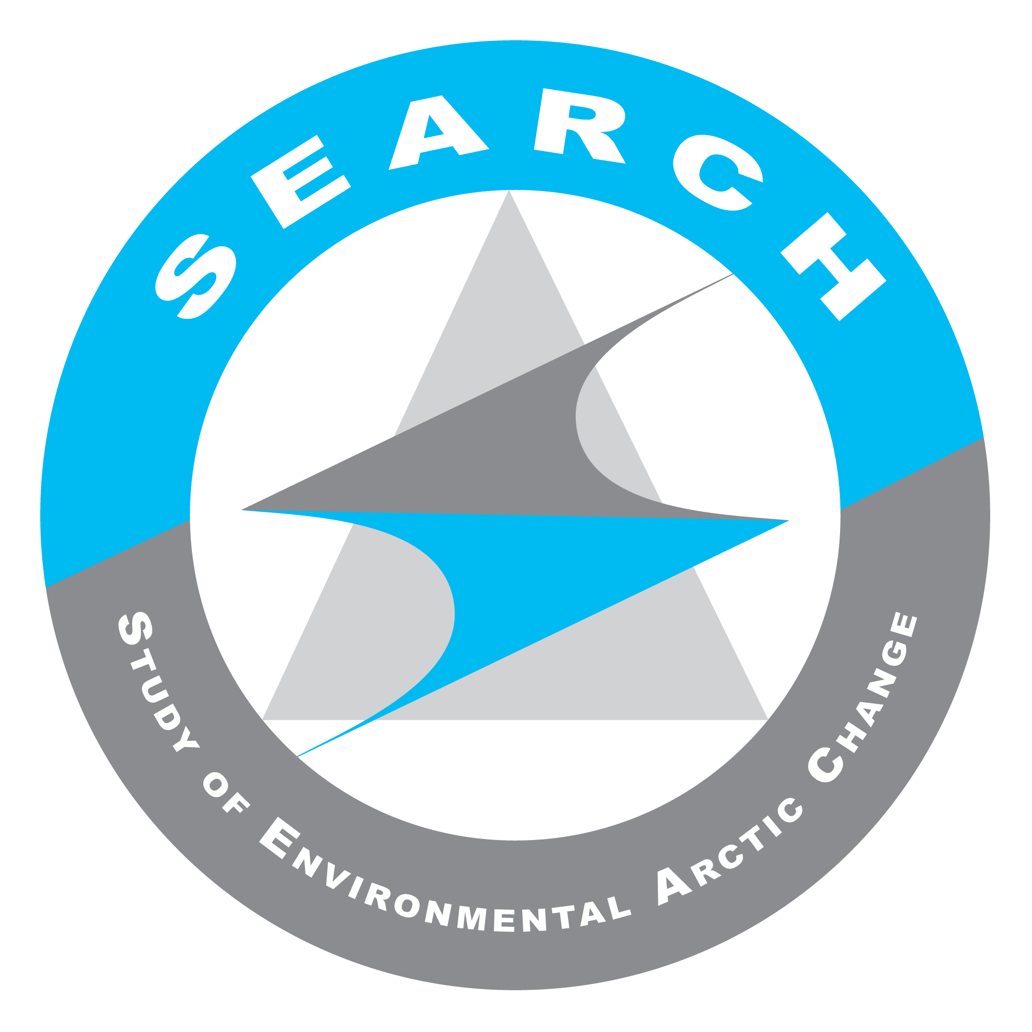
SEARCH SSC Teleconference
24 August 2015
Summary notes & Action Items

Present on call: Hajo Eicken, Olivia Lee, Helen Wiggins, Brit Myers, Lisa Sheffield-Guy, Henry Huntington, Ted Scambos, Christina Schädel, Jennifer Francis, Janet Intrieri, Steve Vavrus, George Kling, Marika Holland, Ted Schuur, Courtney Carothers, Uma Bhatt, Karen Pletnikoff, Dave McGuire, Fiamma Straneo, Dee Williams, Bob Bindschadler, Caspar Ammann, Matt Druckenmiller (Hajo suggested using WebEx in the future to track call contributions from everyone)

SSC Action Items:
- ACTION: SSC/AT Leads should submit their feedback on the AON draft response document to Hajo by 25 August, 9am AK.
- ACTION: Bob & Caspar will summarize the thoughts they shared about AON during the telecon and send them to Hajo in writing.
- ACTION: Dee will see if he can procure the Gaps and Overlaps report Saltzman references in his letter (due to be released June 2015) as it may be a “federal only” resource.
- ACTION: Action Team Leads will need to provide Brendan Kelly details (in writing) about their SEARCH Year Two program plans and science products ASAP after his 21 September start date.
- ACTION: The SSC and Action Team leads should review Ted Schuur’s email detailing proposed Permafrost products & use it to continue thinking about possible cross-cutting theme/collaboration opportunities. Methane release from the seabed has been suggested as one area for cross-team collaboration.
- ACTION: Ted Schuur will make sure ARCUS staff have the necessary details needed to promote additional SEARCH leadership participation at the next Permafrost workshop.
- ACTION: The Sea Ice Action Team will think about how the communication strategies that they develop during their retreat might be applied across SEARCH, making it another cross-cutting focus/theme for all of SEARCH in Year 2 and beyond. An outline of this thinking should be shared with the SSC and other Action Teams after the September retreat.
- ACTION: The Land Ice Action Team will need to outline details for its year two program/product plan prior to the GriOOS AGU workshop. Information on how the Action Team will engage regional stakeholders would be valuable.

SEARCH Science Office Action Items:
- ACTION: ARCUS staff will work with Jeremy Mathis to get SEARCH on the agenda for an IARPC AON collaboration team meeting.
- ACTION: Helen will follow up with Sara Bowden to see if she has any additional information about the Gaps and Overlaps report that Saltzman references in his letter.
- ACTION: The SEARCH ED/ARCUS staff will follow up with Ted Schuur regarding future Permafrost workshop funding.
- ACTION: SEARCH ED/ARCUS staff will work with Land Ice Action Team to address funding concerns related to AGU workshop timing and delay of Year 2 NSF funds.

Summary of Discussions:

- Hajo suggested using WebEx for future calls due to large # of call participants.

- Welcome (Courtney, Marika & Dee)
  - Introduction of new SSC Members joining the call
    - Courtney Carothers is a Cultural Anthropologist at UAF’s School of Fisheries and Ocean Sciences and hopes to bring more of an Arctic community perspective to SEARCH’s work/activities. Learn more about her current research projects here: https://www.sfos.uaf.edu/directory/faculty/carothers/
    - Marika Holland is a Senior Scientist with the National Center for Atmospheric research (NCAR) and hopes to work with SEARCH on improving the links between the Arctic’s observational and climate modeling research activities. Learn more about her current work here: http://www.cgd.ucar.edu/staff/mholland/?_ga=1.258187341.692358133.1434477136
    - Dee Williams supervises the Environmental Sciences Management Section in BOEM’s Alaska Region. His work overlaps with many agencies/committees/observing network activities that are of interest to SEARCH and Dee will be able to help strengthen those network ties. Learn more about Dee’s work here: https://www.linkedin.com/pub/dee-williams/53/727/902

- NSF Response to Arctic Observing Network White Paper (Hajo & Helen)
  - Background: In 2014, NSF held a series of webinars inviting community input on Arctic Observing Network (AON) governance. SEARCH responded to this engagement effort by producing an AON-focused white paper (http://www.arcus.org/search-program/aon). In July 2015, Eric Saltzman (on behalf of the NSF Arctic Section) hand delivered a response to this white paper to Hajo Eicken (SSC Chair) and Craig Lee (Observing Change Panel Chair). There is now an immediate need for the SEARCH SSC to share this NSF response with the Arctic research community. However, Hajo & Craig do not want to do this without also offering some context and proposing a strong community vision for achieving the kind of international AON needed to support science and policy development long-term.
  - Hajo/Uma/Craig will be meeting 25 August to further develop the draft response document that was distributed to the SSC/AT Leads prior to the 24 August telecon. Through Uma’s current role as Director of NOAA’s Cooperative Research for Alaska Institute (CIFAR), Hajo and Uma also hope to leverage this vision document in a white paper to advise NOAA on the potential AON leadership role the agency can play.
  - ACTION: SSC/AT Leads should submit their feedback on the AON draft response document to Hajo by 25 August, 9am AK.
  - There is also a current effort underway by Hajo/Craig/Olivia/SEARCH staff to map the AON priorities that have been expressed by the research community to research projects that have recently been funded by NSF and at interagency scales. This is being done to assist NSF funding panels allocate limited funds available in upcoming grant cycles to research projects that best match community priorities and to fill gaps missing in existing research.
  - The AON vision document as well as the findings from the research priorities mapping work will have many opportunities to be shared with the Arctic research community in the weeks and months to come, including the Conference on Global Leadership in the Arctic (GLACIER) in Anchorage this month and the March 2016 Arctic Observing Summit in Fairbanks. The Arctic Observing Open Science meeting this November in Seattle is also a venue for communicating this AON vision, although the focus of this meeting is more about identifying research results/findings that have already been produced by existing AON components.
    - Action Item: SSC Members & AT Leads should encourage groups that can play a role in enhanced AON coordination (including other SEARCH members and the Observing Change Panel) to participate in the Arctic Observing Summit and to submit something to their current call for white papers: http://www.arcticobservingsummit.org/community-white-papers-and-short-statements-submission-form
  - SSC/AT Leads Discussion:
    - Uma asked if there was any concern that the “Governance” statements made in the Saltzman might constitute the full extent of what NSF will commit to on paper. Hajo felt that people like William Ambrose, NSF’s new AON program officer, are still open to improving AON governance in collaboration with the research community and that this should not be a concern.
    - Hajo asked for Dee’s perspective on building sustained observation support within NSF/BOEM/other federal agencies. Dee said he believes IARPC is helping, but it is slow work. He asked if this letter could be used in any way to help accelerate this inter-agency cooperation dynamic. Hajo believes the new co-chairs of IARPC’s Arctic Observing Collaboration team (Sandy Starkweather & Jeremy Mathis) might be able to help with this.
      - Action Item: ARCUS staff will work with Jeremy Mathis to get SEARCH on the agenda for an IARPC AON collaboration team meeting.
    - Caspar felt that there is a need to make a distinction between SEARCH’s specific response to NSF and developing a vision that will be relevant to a broader international/interagency audience. The current response document may focus too much on SEARCH’s previous interactions with NSF for it to clearly articulate the AON vision needed to engage a wide range of audiences. He suggests creating a document that first describes the AON vision that can then be followed up with additional pages outlining how NSF can specifically support that vision. As other agencies are engaged, additional sections can be added outlining their AON role. He felt SEARCH should be focusing on two parallel paths in the months to come - 1. a response to Saltzman with a NSF focus for AON and 2. engaging the broader Arctic research community to develop an interagency/international AON system.
    - Bob warned against being too passive or reactive with a response. He emphasized that, as representatives of the research community, SEARCH should be a driver, telling what we need from the agencies in order to support science across boundaries and demanding that agencies find a way to work this way too. AON is an obvious focus for pushing agencies to work together. Program managers must be held responsible for solving the problem. Can’t let them escape.
      - Action: Bob & Caspar will summarize the thoughts they shared about AON during the telecon and send them to Hajo in writing.
    - Dee wanted to make sure that he understood the urgency behind developing this response and why more time could not be taken to further clarify the vision and communication strategy. Hajo said that the urgency came from the need to share the NSF document with the broader research community asap, as NSF had simply hand-delivered the communication to Hajo/Craig. They did not, however, want to publicize the document without providing context and a vision to mobilize a response within the community. George did not think simply posting the NSF document to the SEARCH website along with a statement that “more information to come” was a good way to go. He promoted developing a stronger response now and releasing a more complete PDF package that included 1. SEARCH’s original AON white paper, 2. Saltzman response & 3. SEARCH’s AON vision document.
    - Dee felt the Gaps and Overlaps report Saltzman mentions might be a good resource for to engaging stakeholders. Helen confirmed the June 2015 release date was accurate but there has been no public distribution of the reportat that it may be a “federal only” resource.
      - ACTION: Dee will see if he can procure the Gaps and Overlaps report Saltzman references in his letter.
      - ACTION: Helen will follow up with Sara Bowden to see if she has any additional information about the Gaps and Overlaps report that Saltzman references in his letter.

- SEARCH Executive Director Hire Update (Hajo)
  - Hajo announced that Dr. Brendan Kelly accepted the offer of the SEARCH Executive Director position and that he will officially begin his SEARCH duties 21 September. His first priority will be developing SEARCH’s Year Two program plan. Brendan has also already agreed to participate in the Sea Ice Action Team strategy meeting this September and will be a contributor to the Sea Ice Action Team’s session at AGU.

- Year 2 SEARCH Product Planning (Action Team Leads & Hajo)
  - ACTION: Action Team Leads will need to provide Brendan Kelly details (in writing) about their SEARCH Year Two program plans and science products asap after his 21 September start date.
  - Permafrost Action Team (Ted Schuur)
    - Ted circulated a document prior to the 24 August Telecon that details a number of proposed Permafrost synthesis products that have gained traction within the Permafrost Carbon Network.
      - ACTION: The SSC and Action Team leads should review Ted Schuur’s email detailing proposed Permafrost products & think about possible cross-cutting theme/collaboration opportunities. Methane release from the seabed may be one area for cross-team collaboration.
    - Prior to AGU there will be a Permafrost workshop to push these products forward.
      - ACTION: Ted Schuur will make sure ARCUS staff have the necessary details needed to promote additional SEARCH leadership participation at the next Permafrost workshop.
      - ACTION: The SEARCH ED/Science Office will follow up with Ted regarding future workshop funding.
  - Sea Ice Action Team (Jennifer Francis, Matt Druckenmiller)
    - Much of the Sea Ice Action Team’s future will be mapped out by the 9 individuals participating in the Sea Ice Action Team’s Sept. task force. The Action Team’s long-term vision, communication strategy, goals, and the people/skills needed to achieve those goals will all be identified during this planning retreat. Brendan and Marika will both be there.
    - The pre-AGU science communication workshop that the Sea Ice Action Team is developing with Andy Revkin could be packaged as a Year 2 workshop product for the Arctic Science
    - ACTION: The Sea Ice Action Team will think about how the communication strategies that they develop during their retreat might be applied across SEARCH, making it another cross-cutting focus/theme for all of SEARCH in Year 2 and beyond. An outline of this thinking should be shared with the SSC and other Action Teams after the September retreat.
  - Land Ice Action Team (Fiamma Straneo & Ted Scambos)
    - The primary focus for the Land Ice Action Team in Year 2 will be the development of the Greenland Ice Ocean Observing System.
    - The Action Team is hosting a workshop focused on this Dec 12-13th before AGU. Expressions of interest for the workshop were due 22 August. About 30 individuals with good international and stakeholder representation were included in these interest statements. There will also be another 10 individuals from the steering committee participating. The workshop will also be coordinated with a neighboring meeting on ice sheet modeling sponsored by CLIC.
      - ACTION: SEARCH ED/ARCUS staff will work with Land Ice Action Team to address funding concerns related to AGU workshop timing and delay of Year 2 NSF funds.
    - Throughout the remainder of Year 2, a post-workshop report will be written to identify GrIOOS priorities, establish an implementation plan, and promote action within the existing network of international agencies that would contribute to GrIOOS development.
    - In Year 2 a post-doc will be selected to work between WHOI and NSIDC on Land Ice Action Team activities
    - Although the direction that the Land Ice Action Team has taken to date has been more about coordinating existing efforts for measurements to be made, there is also an opportunity to take the lead in the development of new products/assembling new data sets.
      - ACTION: The Land Ice Action Team will bring up synthesis product development at the GrIOOS workshop.
    - ACTION: The Land Ice Action Team will need to outline details for its year two program/product plan prior to the GriOOS AGU workshop. Information on how the Action Team will engage regional stakeholders would be valuable.
  - Cross-cutting efforts (Hajo):
    - During the last in-person SSC meeting there was a discussion about identifying state variables for Arctic system. This is something else to keep on the table for cross-cutting synthesis products for Year 2.
    - Caspar emphasized the pressure NSF is facing to document the social benefits produced by the work the agency funds. As products are developed, plans for evaluating product impact should also be incorporated (measures of direct action, economic impact, etc).

- In-person SSC/AT Lead Meeting Update (Helen & Hajo)
  - Currently the best dates for the in-person meeting appear to be October 20 & 21. However, the decision to hold the meeting on these dates may need to be made before a new SSC Chair has been identified. There is an equal amount of urgency to make sure year 2 planning proceeds, however, and Hajo feels strongly that this meeting should move forward regardless of the SSC Chair rotation status.

##Regular meeting adjourned, convened into Executive Session##

