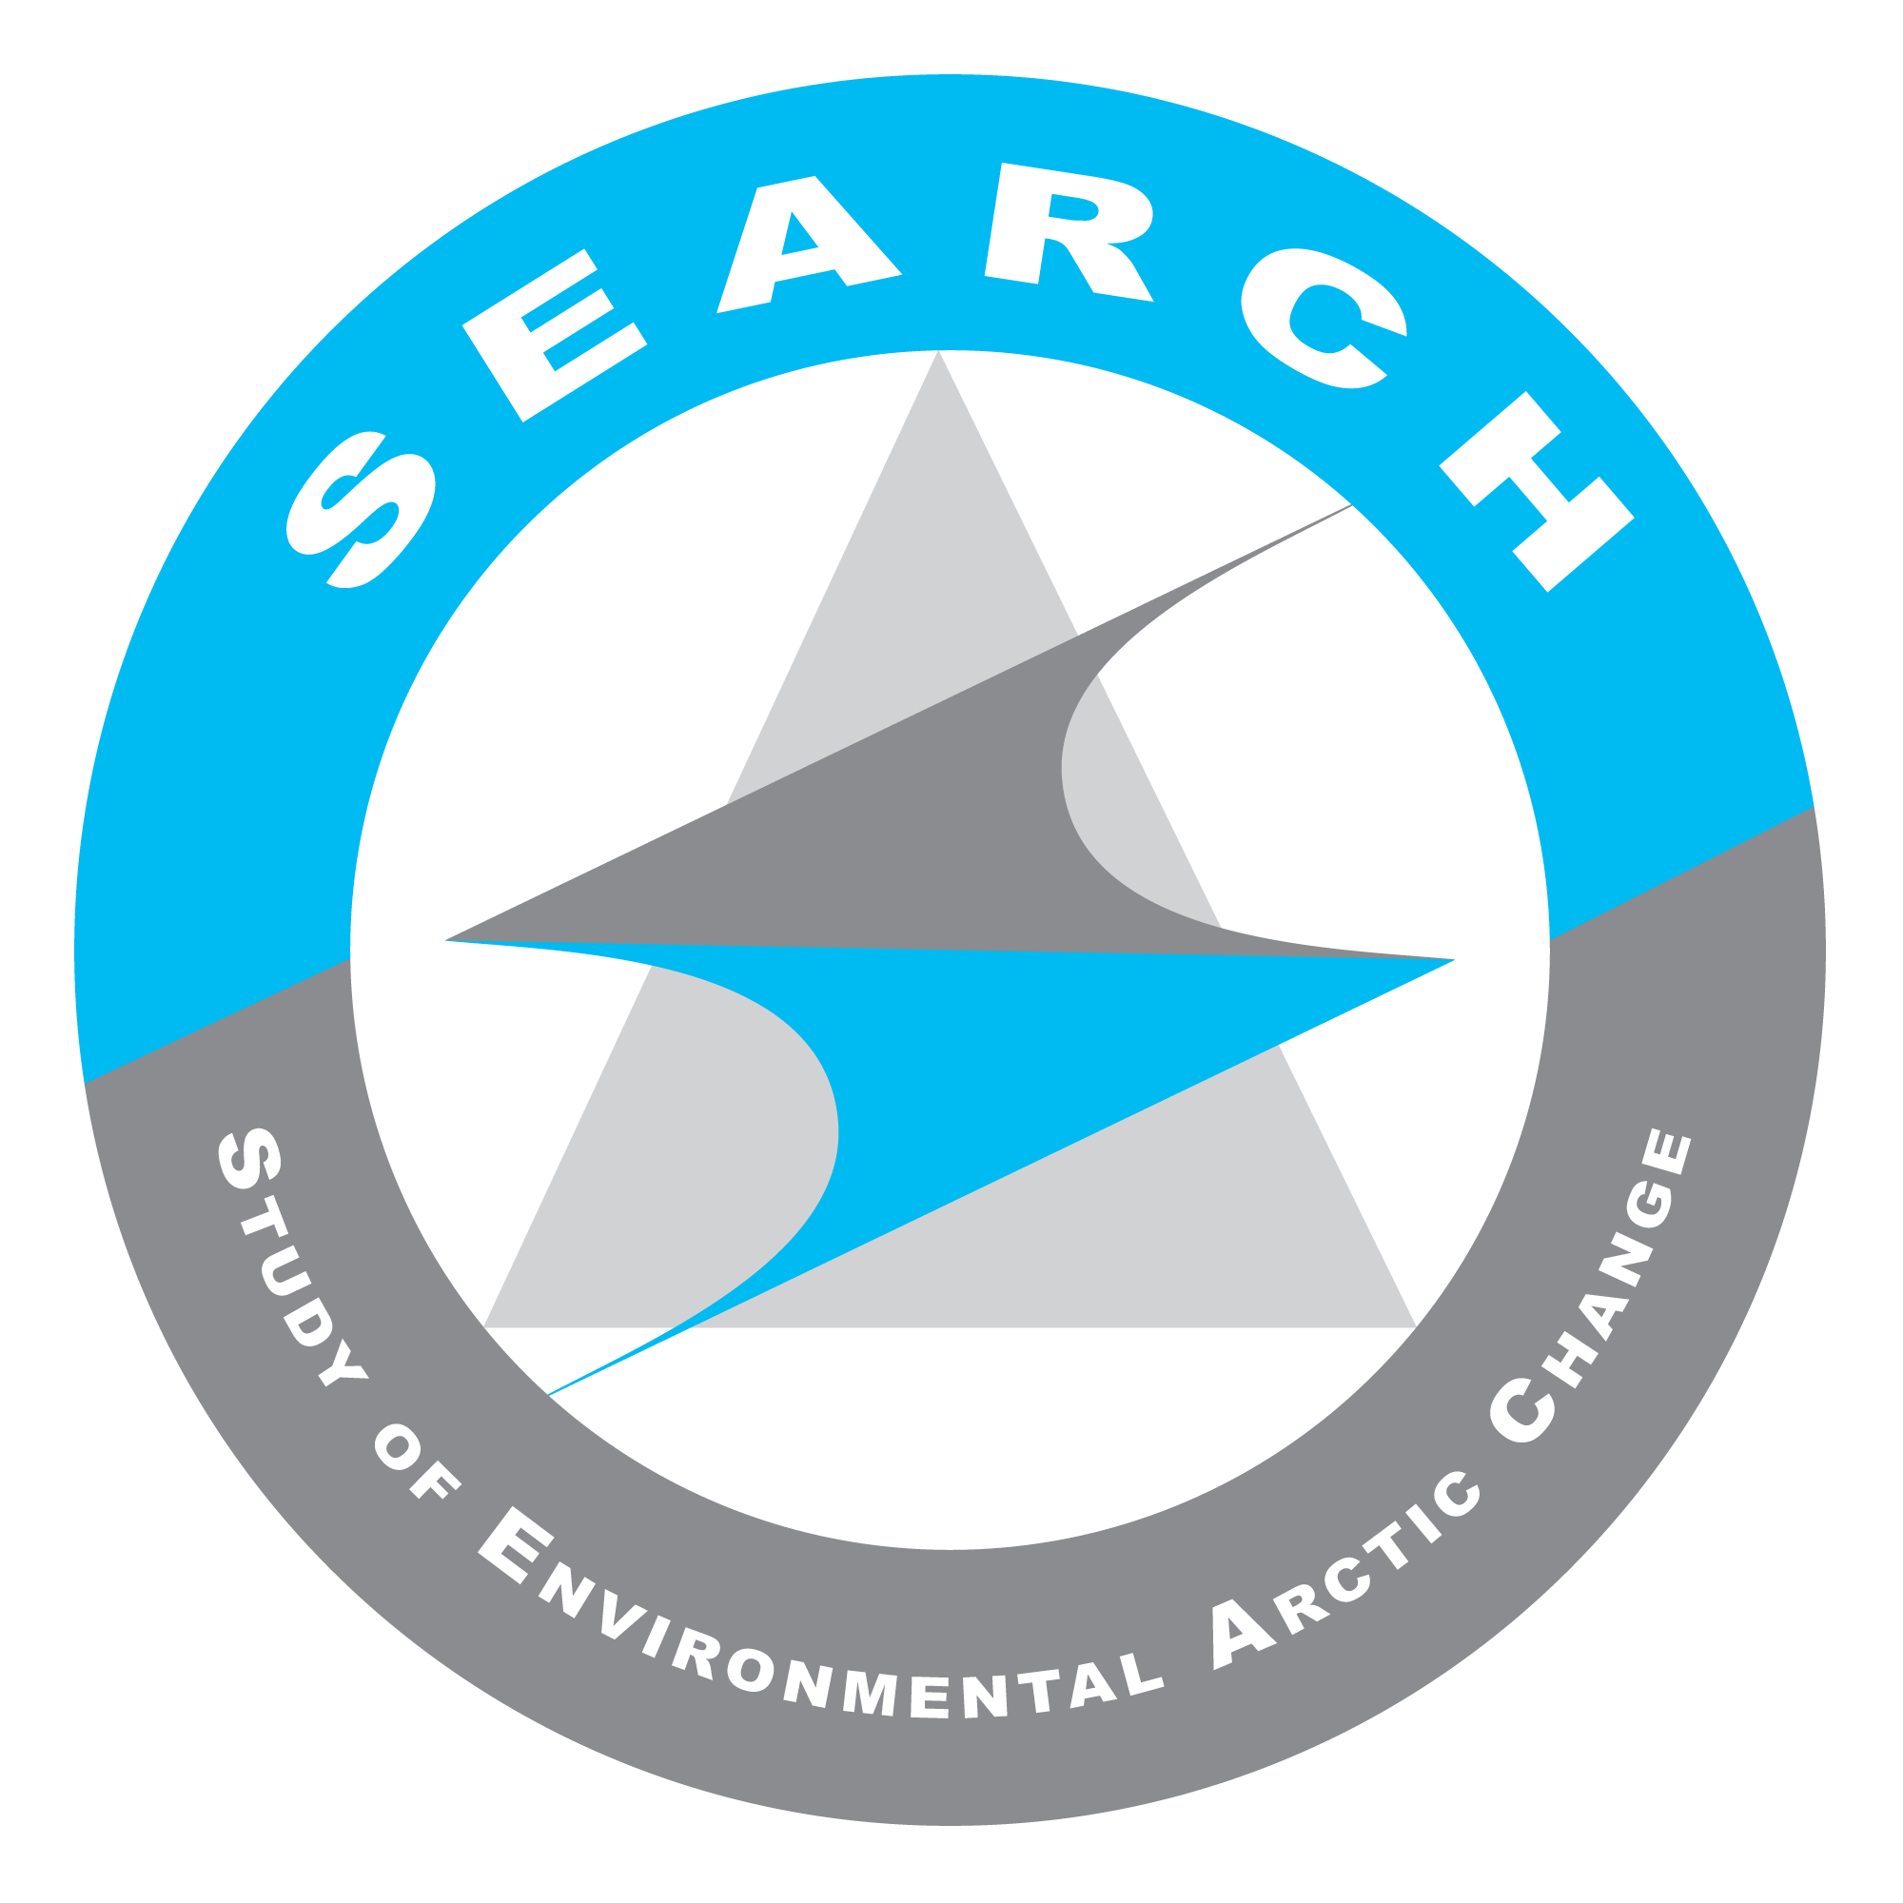
SEARCH SSC Teleconference
17 July 2015
Summary notes & Action Items

Present on call: Hajo Eicken, Olivia Lee, Henry Huntington, Ted Scambos, Uma Bhatt, Jennifer Francis, Janet Intrieri, Steve Vavrus, Karen Pletnikoff, Dave McGuire, Helen Wiggins, Brit Myers, Lisa Sheffield-Guy

Summary of Discussions & Action Items:

1. Welcome to new SSC members
- Courtney Carothers & Marika Holland have joined the SSC this month.

2. Update on SEARCH ED hire process (Uma Bhatt)
- Second round interviews of the two SEARCH Executive Directors (Dr. Brendan Kelly and Dr. Frank Rack) took place at UAF 2 and 3 weeks ago, respectively.
- ACTION: The SEARCH ED hiring committee will meet Monday 20 July to outline travel requirements for the candidates and discuss any final issues before making an official hiring offer.

3. SEARCH Annual Report Draft
- The main SEARCH report, Action Team sub-reports, budget updates from IARC & ARCUS and the draft SEARCH Terms of Reference were sent to NSF for review and feedback.
  - Hajo Eicken reported on the in-person feedback he received on these items from NSF staff yesterday.
    - Neil Swanberg (NSF Program Officer) liked the report format.
    - NSF noted science deliverables are behind schedule but understood the delays associated with populating Action Teams.
    - ACTION ITEM: NSF strongly emphasized the need to produce a more detailed Year 2 Program Plan and Year 2 Budget as soon as the SEARCH Executive Director is hired.
    - NSF agreed to a no-cost extension of SEARCH funding for Year 1.
    - The no-cost extension will allow Action Teams to continue using Year 1 sub-award funding for the remainder of the year.
    - Year 2 would use Fiscal Year (FY) 2016 so would be funded after 1 October 2015, which would also benefit NSF as they are overcommitted for this FY. Funding would be available early 2016.
  - Jennifer Francis noted that the no-cost extension will need to be in place this month to allow her to extend use of funds through Rutgers.
  - ACTION: Helen/ARCUS will follow up on no-cost extension requirements
    - More information on specific no-cost extension paperwork needs from Jennifer Francis/Rutgers required.

4. SEARCH Action Team Updates
- Land Ice Action Team (Ted Scambos)
  - Ted discussed plans for the fall GrIOOS workshop, links to GrISO, and the international nature that the Land Ice Action Team is developing as a result to the parallel activities it is taking with GrISO.
  - ACTION: Ted/Fiamma to email the SSC more information on how they plan to integrate stakeholder engagement and any “knowledge to action” components planned for the GrIOOS workshop this fall.
- Sea Ice Action Team (Jennifer Francis & Henry Huntington)
  - The hire of Matthew Druckenmiller as the Action Team’s Facilitator/Communicator was announced.
  - Jennifer reported on Matt’s progress preparing for the Strategy Task Force workshop to be held 9-10 September in Rhode Island.
    - The small Strategy Task Force workshop will support the Sea Ice Action Team’s efforts to scope activities, develop a strategy for science communication and identify member needs/targets for Action Team population.
  - Part of Matt’s role will be to connect with Alaska communities and stakeholder groups.
    - ACTION ITEM: Jennifer/Henry will put Matthew in touch with Karen Pletnikoff to find out if there might be other opportunities to link Sea Ice Action Team efforts to workshops currently taking place in Alaska.
  - Jennifer also announced the Team’s AGU Session and speakers.
    - One of the speakers - Andy Revkin (The New York Times Dot Earth Blogger) plans to hold a side workshop at AGU on science communication targeted toward early career scientists.
    - The AT plans to package the workshop for later use at the Arctic Summit
- Permafrost Action Team (Dave McGuire)
  - A dozen synthesis projects for the Permafrost Carbon Network were identified at the May Permafrost Carbon Network workshop in Flagstaff.
  - Permafrost Action Team leads participated in the “Our Common Future Under Climate Change” conference in Paris this month where they presented on the current knowledge synthesis of permafrost carbon feedback.
  - In addition to the work of the Permafrost Carbon Network, the Permafrost Action Team will also focus on infrastructure and the effects of permafrost change on natural resources.
    - Members of the Permafrost Action Team will represent each of these three focus areas:
      - 2-3 members of the Permafrost Carbon Network
      - 2-3 members focused on infrastructure issues
      - 2-3 members focused on impacts to natural resources
      - ACTION: Helen/ARCUS to help close loop regarding the Permafrost Action Team member nominations submitted to the SSC for approval.
    - Once members are in place, the production of team scoping documents is a likely next step.
  - The next Permafrost Carbon Network meeting will take place the Sunday before the AGU 2015 Fall Meeting. An Action Team meeting may also be planned around AGU.
  - The International Conference on Permafrost will take place 20-24 June 2016 in Potsdam, Germany. This may be another good opportunity to plan a future Permafrost Action Team meeting around.
- Action-Team Coordination & Synthesis
  - Jennifer Francis asked about progress other Action Teams have made hiring post-doc researchers to support activities and whether there may be ways to coordinate these activities across the Action Teams.
    - Ted Scambos reported the Land Ice team is not close to making a decision at this time but circulating a list of names/specialties prior to selection might help ensure a good representation/diversity of skills.
    - Dave reported that Christina Schädel coordinates the Permafrost Carbon Network and has also assumed coordination of the Permafrost Action Team.
      - ACTION: Ted Schuur/Permafrost should let the SSC know more about any plans for a coastal processes/Climate Science Center research associate.
  - Hajo pointed out the study of subsurface methane as a unifying theme for Year 2 program planning and highlighted its relevance to the objectives of the US Arctic Council Chairmanship

5. Arctic Observing Network (AON) D.C. Discussions (Hajo)
- Hajo & Uma met with several individuals and groups in DC to discuss AON needs/opportunities:
  - Meetings with NOAA staff included: Laura Furgione, Dave Legler, Jeremy Mathis, Kathy Crane, and others.
  - Simon Stephenson (IARPC/OSTP) is focusing heavily on events being planned around the US Chairmanship of the Arctic Council. He had less detail to offer on IARPC.
  - Sherri Goodman indicated that the Consortium for Ocean Leadership is not currently doing anything in the Arctic but that there is an interest in establishing a connection with SEARCH and that they could help with international community connections.
  - The NOAA meeting revealed an interest in further developing their SEARCH collaboration
    - ACTION: Uma and Hajo will develop a white paper outlining opportunities for SEARCH to better engage with NOAA
      - The SEARCH ED will be key to building this relationship
      - SEARCH can support cooperative institute relationship building
      - Regarding AON, NOAA will be building out observation platforms but will not have capacity to do this alone. The white paper can help demonstrate the role the research community might play in developing a joint observing system and highlight key pieces of the network that may not be otherwise be identified as priorities by NOAA.
  - Hajo and Craig Lee met with several NSF staff:
    - William Ambrose (new NSF AON Program Officer) was part of the larger NSF Polar group that met with Hajo and Craig to talk about SEARCH. A 1:1 discussion with Will about AON was not possible.
    - NSF’s last round of AON funding proposals are still pending and NSF is still looking for reviewers. A panel review of these proposals is not likely to take place before fall or before the fall 2015 NSF Announcement of Opportunity
    - Eric Saltzman provided Hajo and Craig a written response to the AON Position Paper that SEARCH finalized and published in April 2015.
    - Craig and Hajo also met with Bob Houtman, NSF Division of Ocean Sciences, who discussed examples of different mechanisms for longer-term funding at NSF.
    - One message overall from the NSF visits was that SEARCH could help more with advertising funding opportunities in Polar Programs and by other NSF programs.
    - ACTION: Helen/ARCUS to share Eric Saltzman’s written response to AON position paper with the SSC/AT Leads when we receive a digital copy.
    - ACTION: ARCUS to follow-up on different ways to communicate and encourage submissions to relevant NSF funding announcements.
    - ACTION: Hajo encouraged the SSC/AT Leads to send Craig Lee input on how best to respond if NSF AON funding has significant cuts. Any examples of how long-term observing has been supported by other agencies &/or outside the Polar Science division within NSF would also be useful.
    - The fall AOOSM meeting seems to be perfectly timed to demonstrate the role that NSF’s funding of AON has played in answering important science questions. The SEARCH SSC has an important role to play in encouraging the Arctic research community to attend and to publicize the meeting’s key messages/outcomes.
      - ACTION: Olivia Lee will be looking into the AON activities within the larger research community and can serve as an info source for ARCUS staff/others who may be doing similar work.

6. Terms of Reference (ToR) Draft
- A draft Terms of Reference document for SEARCH program governance was distributed to the SSC as an attachment to the call agenda. The components follow previous decisions and discussions by the SSC, and this version of the ToR provides more formalized language.
  - ACTION: SSC Members should read through the ToR and raise any final questions or concerns about the document by email next week.
  - ACTION: Helen/ARCUS staff will distribute an electronic poll to the SSC so they may vote on the adoption of the ToR by Friday, 25 July 2015.

##Regular meeting adjourned, convened into Executive Session##

