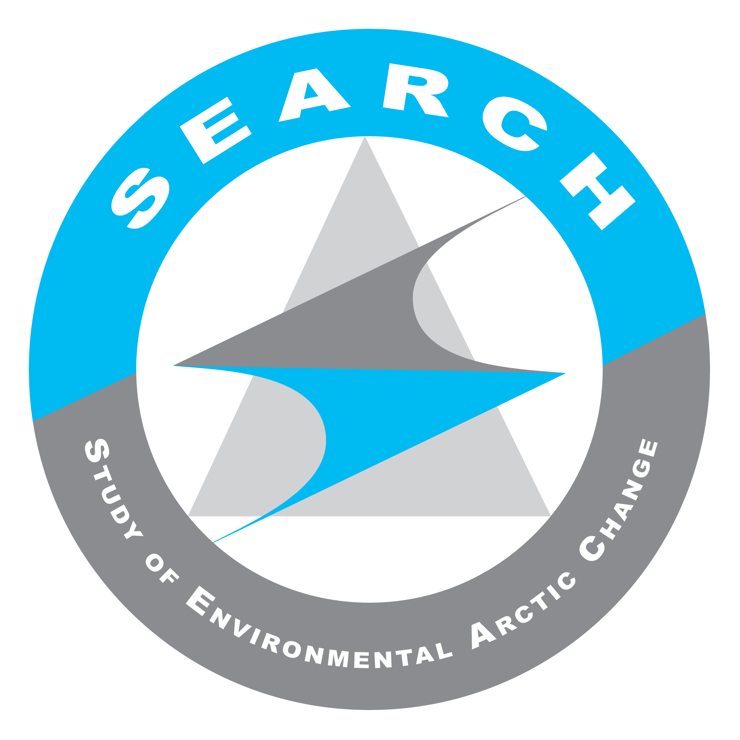
SEARCH SSC Teleconference
22 September 2015
Summary Notes & Action Items

Present on call: Brendan Kelly, Hajo Eicken, Olivia Lee, Helen Wiggins, Brit Myers, Lisa Sheffield-Guy, Bob Rich, Christina Schädel, Ted Schuur, Jennifer Francis, Matt Druckenmiller, Ted Scambos, Fiamma Straneo, Bob Bindschadler, Dee Williams, Karen Pletnikoff, Steve Vavrus, Betsy Baker, Uma Bhatt, Dave McGuire, Caspar Ammann, Marika Holland, George Kling

Action Items:

AON Priorities/Project Tables Sent to NSF:
- ACTION: Make sure in follow-up conversations with Will Ambrose that the process of developing the tables was clear and took as intended, including the fact that SSC/OCP members who had pending grant proposals did not provide input b/c of potential conflict of interest (Hajo or Craig)
- ACTION: Help SSC to identify how else to use the document for strategic planning of SEARCH-AON and potential synthesis activities (ARCUS)
- ACTION: Keep a running list of how the SEARCH-AON priority documents/tables are being used to inform other activities (ARCUS)

AON Vision Documents
- ACTION: Continue to develop AON Vision documents for discussion at a next SSC/AT teleconference (when Craig Lee is back from sea and can join) (Hajo, Helen, Craig)

Arctic Observing Summit 2016
- ACTION: Finalize plan for SEARCH submission of white papers and/or short statements (ARCUS)

Year 2 Program Plan
- ACTION: SSC and Action Team leads review original proposal to NSF and document any to explain any Year 2 deviations from those original plans/activities. (ARCUS facilitate)

Other:
- ACTION: Any SSC members/AT leads who haven’t already, please complete the latest in-person meeting scheduling poll no later than COB Wednesday, 23 September: http://doodle.com/poll/nurdsair7qy8upxc

Summary of Discussions & Action Items:

- Welcome to new members of the SEARCH team
- New SEARCH Executive Director, Brendan Kelly is in Fairbanks this week.
- New SSC member, Betsy Baker will also be in Fairbanks for the Polar Law Symposium 23-24 September. She is a law professor working on law of the sea and offshore issues.

- Arctic Observing Network/System
- Update on documents comparing SEARCH-AON priorities to funded NSF projects (Lisa)
  - Lisa sent out an email with tables outlining SEARCH’s 2005 & 2009 research priorities and the number of NSF funded projects active in the last two years that have addressed each priority. These were developed by searching the NSF website and reviewing project abstracts. These materials have been shared with NSF. NSF’s AON program officer, William Ambrose sent out a positive response saying SEARCH is seen as a go-to resource.
  - ACTION: Make sure in follow-up conversations with Will Ambrose that the process of developing the tables was clear and took as intended, including the fact that SSC/OCP members who had pending grant proposals did not provide input b/c of potential conflict of interest (Hajo or Craig)
  - ACTION: Help SSC to identify how else to use the document for strategic planning of SEARCH-AON and potential synthesis activities (ARCUS)
  - ACTION: Keep a running list of how the SEARCH-AON priority documents/tables are being used to inform other activities (ARCUS)
- Update on AON vision documents including a package that might be useful for the U.S. Arctic Executive Steering Committee (Hajo)
  - A SEARCH AON vision document would assist federal leaders (Kathy Sullivan, NOAA Administrator/John Holdren, ED of Arctic Exec Steering Committee) identify which agency is responsible for various AON components and support integration efforts.
  - Key point – The AON vision document will lay out more clearly the boundaries and overarching efforts. Who has responsibility for different aspects of sustained observations and how do you bring them together?
  - Hajo’s recent conversations with Jeremy Mathis indicate NOAA will increasingly be responsible for the shifts from observation to operations.
  - ACTION: Continue to develop AON Vision documents for discussion at a next SSC/AT teleconference (when Craig Lee is back from sea and can join) (Hajo, Helen, Craig)

- Planning SEARCH white papers for the 2016 Arctic Observing Summit.
  - White papers/short statement submissions are due October 18. See link for details: http://www.arcticobservingsummit.org/community-white-papers-and-short-statements-submission-form
  - Perhaps one overall paper from SEARCH (our vision for AON), then one from each Action Team?
    - The white paper that SEARCH produced for the first Arctic Observing Summit is now being picked up and put to use.
    - White papers are good because they help us keep track of where we are in progress with our vision.
    - The AON vision document could help inform an overall SEARCH white paper for this summit.
    - The Greenland Ice Sheet Observing System is a perfect candidate for a white paper topic. The deadline for white paper submission (Oct 18) is before the GrIOOS workshop in December. An update to anything submitted in Oct could be made in January, however, after the workshop has taken place.
    - Following on Olivia’s assessment of observing resources last year, we could follow up with specific suggestions for integrating projects.
    - These white papers will be well-placed to inform the work of the Sr. Arctic Officials/Arctic Council Working Groups that will be meeting in parallel with the Arctic Observing Summit.
    - ACTION: Finalize plan for SEARCH submission of white papers and/or short statements (ARCUS)

- Additional thoughts on Year 2 science products for inclusion in the Year 2 program plan; timing and process of developing Year 2 program plan.
- ACTION: SSC and Action Team leads review original proposal to NSF and document any to explain any Year 2 deviations from those original plans/activities. (ARCUS facilitate)

- De-brief on Sea Ice Action Team Strategy Task Force meeting (Jennifer)
- The nine-person SIAT Task Force met in Rhode Island earlier in September.
- A write-up of the meeting was distributed by Lisa to the SEARCH SSC/AT Leads in advance of the 22 September telecon and may be consulted for further details.
- The Sea Ice Action team intends to be the go-to/authoritative/rapid response information source for all- things sea ice, specifically targeting scientific, decision-making and news/media audiences.
- Website development is planned as are invitations to the broader sea ice community to contribute content.
- There is a need to determine if the significant effort required to produce this go-to website something we currently have resources for. The SIAT can look into finding additional resources for this with help from the SEARCH project office
- Developing prototypes for 1-2 “knowledge pyramids”/topical website content related to themes such as “Sea Ice and the Ecosystem” and “Sea Ice and Weather” is planned as a next step.

- Other Action Team News/Updates
- Permafrost (Ted Schuur)
  - A draft agenda for the Permafrost Carbon Network meeting planned for December 13/pre-AGU in San Francisco has been developed. An open meeting to discuss synthesis activities is planned for the morning, working group meetings are planned for the afternoon.
  - AGU has also invited a special session on Permafrost synthesis activities on Thursday December 18. This will include a panel discussion focused on synthesis and linking high-level projects
  - The Action Team is working on leveraging additional funding for future workshops & fund post-doc activities.
- Land Ice (Fiamma & Ted Scambos)
  - The main focus right now is the Greenland Ice Sheet Ocean Observing System (GrIOOS) workshop planned for Dec 12-13 in San Francisco at Fort Mason.
  - They know who will attend: 40 participants with representation from 7 countries, 10 students/post-docs, a number of Greenlanders from different sectors.
  - They’ve received additional funding from CLiC to support the workshop.
  - The workshop will take place parallel to an ice sheet modeling meeting and joint sessions between the two groups are being planned.
  - William Ambrose (NSF AON Program Officer) or other NSF personnel will attend.
  - A publishable document is one of the goals/outcomes for the meeting.

- In-person SSC/AT Lead Meeting
- November dates (Nov 4-5, if possible) are now being explored for an in-person meeting to be held in Washington D.C., Boulder, CO or Seattle, WA.
- A video-conferencing component will be added to try and engage individuals who can not attend in person.
- It would be nice to have NSF representation & NOAA’s Jeremy Mathis at the meeting. Mathis will be at AOOSM but can’t meet Nov 4&5.
- ACTION: Any SSC members/AT leads who haven’t already, please complete the latest in-person meeting scheduling poll no later than COB Wednesday, 23 September: http://doodle.com/poll/nurdsair7qy8upxc

##Regular meeting adjourned, convened into Executive Session##

EXECUTIVE SESSION - SSC & STAFF
- SSC Chair election

