SEARCH Science Management Office
Functions and potential organizational structures

(1) Functions and activities of a Science Management Office (SMO)

This list of functions of the SMO is a synthesis of information taken from the interviews with the SSC, and the activities describe how the SMO might carry out its functions. Note that the term “SMO” as we are now using it encompasses all parts of the SEARCH enterprise, including the SSC, the panels or working groups, and a “logistics office” which would provide logistical support similar to the role ARCUS plays now.
Functions:
1. Support arctic science activities
2. Coordinate activities among agencies, scientists, industry
3. Provide information to researchers
4. Identify and develop new science goals and emerging questions
5. Translate and communicate science results to managers and the public
6. Advocate for arctic issues

- Facilitate and support activities furthering arctic research, as guided by the SSC and working groups
  - Primary focus should be on the scientific functions of SSC and the main research questions (panels) as well as organizing the AON program.

- Facilitate coordination between agencies, industry, scientists, and disciplines at both national and international levels
  - Act as a “bridge” between the scientific community and agencies in terms of communicating research needs and funding opportunities
  - Connect science to the planning and decision making needs of regional stakeholders, agencies and the public
  - Provide a framework to support the development of implementation plans (science to action).

- Provide information to researchers, act as a conduit among researchers and funding agencies
  - Provide information for researchers and managers as a “portal” for arctic activities, international programs, upcoming AOs, website updates, etc.
  - Identify gaps using community input, and facilitate workshops, database development, synthesis documents
  - Convince agencies to fund gaps by justifying SEARCH recommendations to IARPC and USARC that result in coordinated AOs.

- Address issues of a rapidly changing Arctic, offer insight into past, present, and future
  - Provide recommendations to USARC on prioritized science questions, goals and objectives in advance of biennial report to Congress; represent a unified voice of the science community (with the “voice” being the synthesis of various workshops or meetings supported by SEARCH or agencies).
  - Work with IARPC on the implementation of science goals and objectives (this is done primarily through the SEARCH Research Goal Panels)

- Translate and communicate scientific understanding (data, projections) into possible actions for stakeholders
  - Work with communities to coordinate and synthesize observations to help with community challenges
  - Translate “State of the Arctic System” understanding to the public.

- Advocate for arctic issues and maintain a “Face of Arctic Research” to the White House and Congress, including specific items such as the law of the sea or adequate funding for icebreakers and infrastructure.
Activities:
- Support for activities including collaborations and synthesis -- Note that the SSC will always work with IARPC or specific funding agencies to develop multi-agency support for such activities.
  - Support SEARCH panel (working group) activities
    - Organize workshops and meetings (logistics for in-person meetings, video conferencing, teleconferences) – proposals for such meetings come from the Panel Chairs and are reviewed and decided on by the SSC (in terms of level of SMO funding).
    - Support science demonstration platforms
    - Organize and support workshops with agency and industry representatives to increase the understanding of needs and thus stimulate funding
    - Support for the creation and distribution of topical white papers
    - Support for special journal issues; op-ed pieces (e.g., EOS)
  - Organize and potentially support science conferences (e.g., 2003 Open Science Meeting) – proposals for such conferences may come from the community at large and are reviewed and decided on by the SSC (in terms of level of SMO funding).
  - Support for coordinated scenario activity (e.g., ice-free Arctic annual meeting)
  - Support for product development or modeling activities that relate directly to advancing the SMO’s functions (e.g., web-accessible models, brochures on dangers of freezing sea spray, etc.)
  - Promote interdisciplinary research – data sharing, data policies, and contributions to analysis in targeted workshops or meetings (proposals for funding support reviewed by SSC).

- Coordination
  - Administrative and technical support for meetings and workshops between SSC, agencies, industry
    - Outreach to agencies to find representatives (program manager level?) for regular coordination meetings; need agency buy-in, work through IARPC.
    - Organize regular briefings with agency representatives, write and disseminate meeting notes.
      - Video conferencing
      - Teleconferences
      - In-person meetings
    - Organize meetings and workshops with international partners.
  - Create and maintain a clearinghouse of the activities of major partners (agencies and academia) to make it easier to compare and generate opportunities for research

- Information for researchers
  - Collect and report results from funded studies or workshops
  - Inform scientific community about upcoming AOs
    - Email newsletter
    - Website updates
    - Reports from SEARCH or SEARCH activities related to upcoming AOs.

- Identify emerging issues and science questions
  - Generate information from the science community (surveys, AGU forum, meetings, etc.) on emerging questions and science needs (e.g., new data needs).
  - Assemble and synthesize information on new science directions
  - Interact with IARPC, ARC, PRB etc. on building a consensus of the most important new science directions
  - Support for an interagency, cross-cutting funding mechanism (e.g., NOPP)
    - Provide administrative and technical support to agencies interested in joint-funding
    - Assist with information needed in drafting AOs, RFPs

- Communication
  - Communicate and educate a broad range of stakeholders, including the public
    - Synthesis of information to directly help people make decisions
      - Promote products to stakeholders (e.g., SIO)
    - News feeds (e.g., ~ weekly digests about current activities, what is coming up, and new challenges)
    - Education - Informational webinars, public outreach, present synthesis of research knowledge to the public, website updates, slides, science updates, demonstration of applications; create a more effective “marketing campaign” of communicators and educators; promote community engagement.

- Advocacy and education to higher levels in agencies
  - Make presentations to IARPC, Congress, White House, Agency heads, etc. about the importance of arctic research.
  - Develop and distribute media (web, brochures) that identifies and highlights important arctic issues.

NOTES FROM SSC CONFERENCE CALL THURSDAY 27 SEPTEMBER:

1. We need to make the distinction between an SMO which encompasses all the components of SEARCH as it stands now (the SSC, working groups, logistical support) and what we have called an “SMO” when we are referring to the logistics support provided by ARCUS. From now on we should refer to the SMO as the entire enterprise, while the role currently played by ARCUS could be referred to as a “logistics office” or some other term.

2. Need to make sure that we integrate “Agencies” within this document.

3. We agreed that the SEARCH SMO should have the ability to fund proposals for workshops, conferences, synthesis products, etc., say in the range of $5-50K. However, these proposals should not include new sample collection or sample analyses, scientific instruments, or other activities judged to be someone’s “individual research project”.
[What about “surveys” of the scientific community by social scientists – that would be considered “new data”, but, if it has the purpose of providing “community input” to SEARCH on emerging or important new directions in research then perhaps such an effort could be considered for support ? ]

4. There was some general unease about the level of specificity that the outline here presents, and the sense that we need more concrete examples to make sure the document doesn’t sound only like “visioning”. One possible way to move forward on this task is to better map the Functions to the Activities (point by point), using examples of past SEARCH products or successes to illustrate what kind of Activity, exactly, we are talking about. As the proposal moves forward in its development we will add the “What will we do next and when” section by bringing in the four main research questions and their specific goals that we have all been working on now for some time.

(2) Potential Structures of a Science Management Office (SMO)
The general structure of a three-level model and a matrix model are presented below. The main difference between the two models is the organization of panels or working groups depicted in the red box in the diagrams (Fig. 1 and Fig. 2). Note also that in our discussions we did not see major differences between the two-level and the three-level models in terms of overall mission and goals. That is, no goals of the SMO are “left out” in either of these models.

A. Three-level model

In the three level model the first level is where scientists are organized around a particular research area or priority goal within SEARCH (e.g. sea ice, permafrost…), the SSC is a separate second level, and there is a third, intermediate level that would examine issues related to coordination of arctic research that are either beyond a ~5-year horizon of a particular research goal (permafrost, etc.) or are integrated across all of the research goals. For example, AON fits into the intermediate level, as would issues of longer-term planning on arctic research priorities or broader-level coordination with the international community. Note that in the two-level model this third level is subsumed within the SSC level.

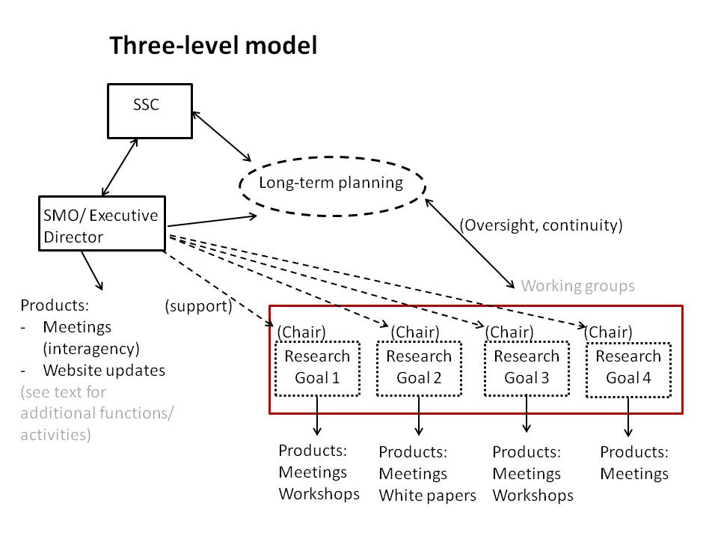

Figure 1. Diagram of the three-level model (Note that “SMO” in this diagram is equivalent to a Logistics Office, e.g., ARCUS).

First level – at the lowest level of structure within SEARCH there would be a group of mostly scientists (and perhaps non-NSF agency program managers) who are currently funded to work in, or are very interested in, or who manage within their agency, a particular research area or question that the community (through SEARCH) or IARPC or ARC has identified as a priority for arctic research. This group will be easy to populate with “volunteers” to serve for some term, and the research area of focus will have a sunset to it of say 3-5 years before being reformed into the next most “urgent” question we need answered or data we need provided. Note that this first level does NOT include AON, because it is a special entity in arctic research that provides cross-cutting information in the form of data to support various of the priority research questions.
This group will have a chair chosen by the SSC, and they will have a charge from the SSC. The charge, basically, will be to carry out activities that make progress in the main goals that we have for SEARCH – this would include functions of information dissemination, involving the larger research community through workshops or conferences, and some form of synthesis through publications or special proceedings from meetings. The group would propose to the SSC how they want to make progress in these main functions of SEARCH, and the SSC would provide support for the activities through the SMO for SEARCH. The group would have a lot of independence on how best to accomplish these functions and activities, and for example there could be different subsets of the group that could be charged by the Chair of the group to guide a specific activity. For example, if some people were interested in having a town meeting with stakeholders, those people would be responsible for making sure that it happens and that the outcomes or products are translated to the group Chair and then to the SSC. Groups in this level could be called “Panels”, and within a panel you might have several “working groups” that form to accomplish specific tasks or activities.

Second level – This intermediate level of structure contains a group of people charged with guiding SEARCH activities at longer time scales than the research questions of the First Level, or which require cross-cutting coordination or integration among the Panels (First Level) or between the Panels and the international community. This could be called the “Long-Term Planning” board or group, and they would for example be responsible for overseeing the AON project. The group would have a Chair and they would talk with the SSC fairly regularly, and would be responsible for holding AON PI meetings and so forth. They would also work closely with NSF program managers for the AON program, but still within some oversight by the SSC. They could propose activities (these might be related to workshops or community events designed to get feedback from researchers on the “next important needs and questions” in arctic research), and the SSC could accept their proposals and provide support through the SEARCH SMO. Just as with the Panels, the Planning Board would be responsible for providing reports or other evidence of “progress” on SEARCH activities to the SSC. Most likely it would be good to have agency representation on this Board (or whatever we call it).

Third level – This is the SSC, and it would function more or less as it does now, but with more involvement with IARPC and ARC in terms of coordinating the “U.S. Science” goals and plans for the Arctic.

B. Matrix model
The matrix model follows the same general structure described above, except that the structure of panels and working groups at the first level is different (Fig. 2). The matrix model maintains the structure of the SEARCH Observing, Understanding, and Responding panels with working group activities (related to the SEARCH 5-year goals such as ice-diminished oceans, land ice/ sea level) cutting across the Observing, Understanding and Responding panels (Fig. 3).

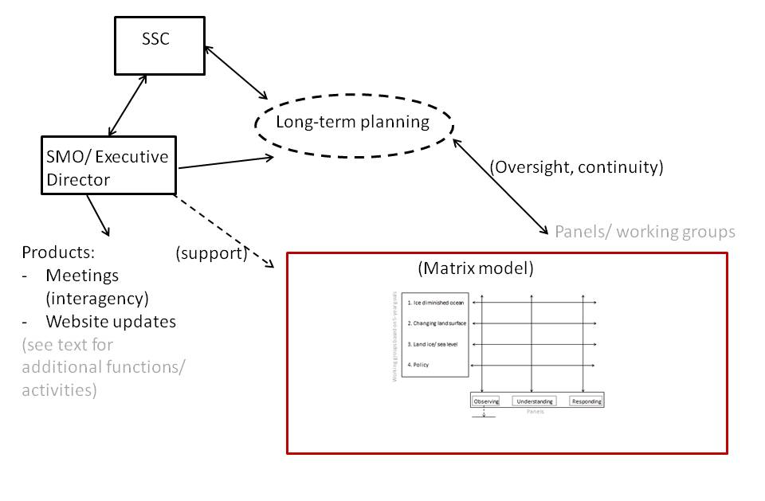
Figure 2. General diagram of the matrix model structure. (Note that “SMO” in this diagram is equivalent to a Logistics Office, e.g., ARCUS)
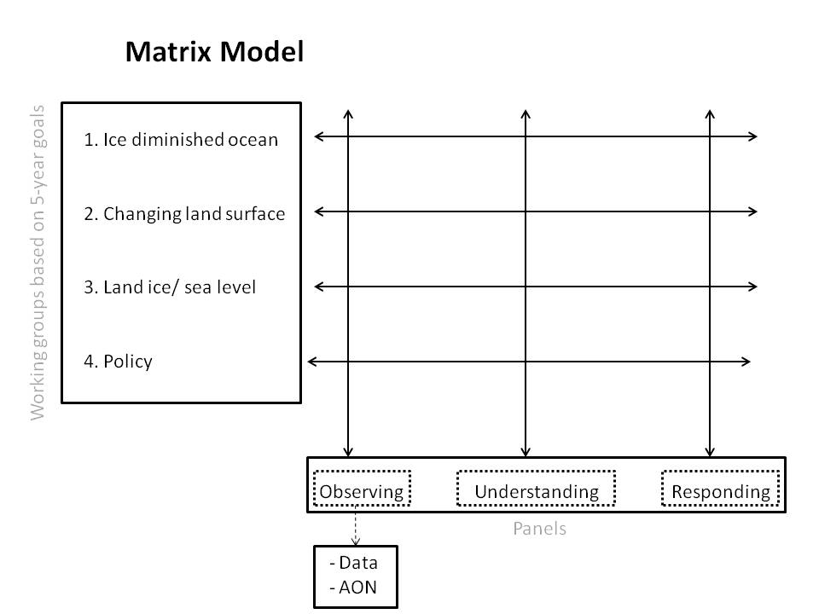

Figure 3. Detailed structure of the matrix model

C. Overall structure
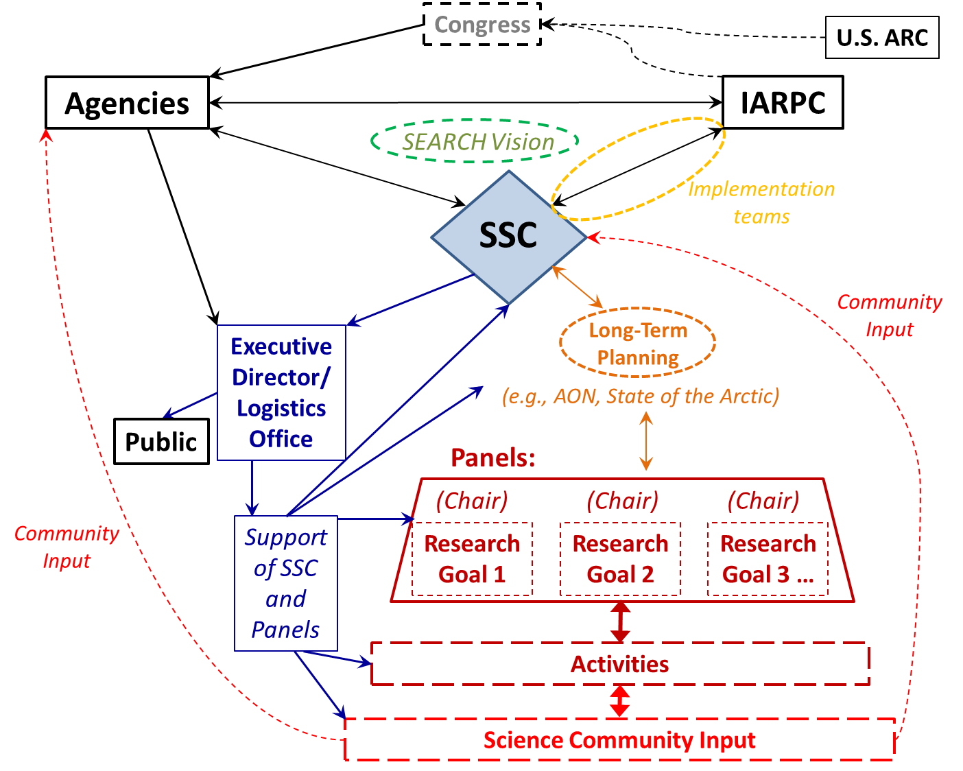
Figure 4. Potential overall structure of SEARCH SMO, SSC, agency and stakeholder relationships

Implementation of the SMO structure

The following issues need to be addressed about the implementation of the SMO structure:
- Who should be the PI for the grant? A scientist?
- What is the role (if any) of the SMO executive director?
- Who would take on the role of the administrative oversight for the SMO/ executive director?
- Where should the physical location of the SMO be?
- What fraction of the SMO would be ‘virtual’ (i.e., telework / presence in Alaska vs Washington DC)?
- Would the structure require a distributed SMO? (e.g. coordination with ACADIS)

